Project Report
on
VERISCOPE TRADE

Submitted in partial fulfillment of the requirements
for the award of the degree of
Bachelor of Computer Applications (BCA)

Uttaranchal School of Computing Sciences



BATCH 2024-2027

Submitted to:
Submitted by:
Ms. Rashmi Kuksal
Aakarshit Bhutani
Assistant Professor
UU2409000001

Uttaranchal School of Computing Sciences
BCA-IV (D)

ACKNOWLEDGMENT
The most awaited moment of any endeavor is its successful completion, but nothing can be done successfully if done alone. Success is the outcome of continuous technical mentoring, guidance, and support from various individuals, and I express my sincere gratitude to all those who contributed to the successful completion of this project.
First and foremost, I would like to thank Prof. (Dr.) Sonal Sharma, Director, USCS, for providing a healthy and encouraging environment for study.
I am extremely thankful to Dr. Sameer Dev Sharma, Head of Department, USCS, and my project mentor Ms. Rashmi Kuksal for providing me with this opportunity and for their valuable technical mentorship, continuous guidance, and expert insights throughout the project development process. Their support at every stage significantly enhanced my understanding and helped me successfully complete this work.
I also express my sincere gratitude to my colleagues for their valuable discussions and support, which helped me in giving a final shape to this project

Dated:
Aakarshit Bhutani
UU2409000001
BCA 4th - D

DECLARATION
I hereby declare that the project titled “Veriscope Trade” is an original work carried out by me under the guidance of Ms. Rashmi Kuksal in partial fulfillment of the requirements for the award of the degree of Bachelor of Computer Applications (BCA) from Uttaranchal University.
I further declare that this project has not been submitted, either in part or in full, to any other institution or university for the award of any degree or diploma.
All sources of information and references used in this project have been duly acknowledged.

Dated:
Aakarshit Bhutani
UU2409000001
BCA 4th – D



Uttaranchal School of Computing Sciences

CERTIFICATE OF ORIGINALITY

This is to certify that the project work entitled “Veriscope Trade” is a bonafide work carried out by Aakarshit Bhutani (UU2409000001) submitted in partial fulfilment for the award of the degree in Bachelor of Computer Applications (BCA) of Uttaranchal University, Dehradun during the academic year 2025-26.

Ms. Rashmi Kuksal
Assistant Professor
USCS

Table of Content

S no. | TOPIC | Page No.
1. | Acknowledgement | II
2. | Declaration | III
3. | Certificate of Originality | IV
4. | Introduction | 6
5. | Objective | 7
6. | System Analysis | 8-26
7. | Identification of Need | 8
8. | Preliminary Investigation | 9
9. | Feasibility Study | 10
10. | Project Planning | 11
11. | Project Scheduling (Pert Chart and Gant Chart) | 12-13
12. | Software Requirement Specifications (SRS) | 14-15
13. | Software Engineering Paradigm Applied | 16
14. | System Model(Data Flow Diagram Lvl -0,1) | 17-18
15. | Control Flow and State Diagram | 19-20
16. | Sequence Diagram | 21
17. | Entity-Relationship (ER) Model | 22
18. | Class Diagram / CRC Model and Use-Case  Diagram | 23-24
19. | Flowchart and Activity Diagram | 25-26
20. | System Design | 27-30
21. | Modularisation Details | 27
22. | Data Integrity and Constraints | 28
23. | Database Design | 28-29
24. | User Interface Design | 29-30
25. | Testing Techniques and Testing Strategies Used | 31-44
26. | System Security Measures (Implementation of Security | 45-47
27. | Reports Generated | 48
28. | Future Scope and Further Enhancements | 49
29. | Appendices (Coding) | 50-98
30. | Snapshots | 99-100
31. | Profile of two IT Companies | 101-102
32. | Bibliography | 103-105

INTRODUCTION
Small retail shops and local vendors generate important business data every day in the form of handwritten sales records, expense notes, and product information. However, most small shopkeepers still rely on traditional notebooks instead of digital systems. This makes it difficult to calculate profit or loss, identify fast-selling or slow-moving products, analyze long-term business trends, or verify the authenticity of products being sold. As a result, decision-making becomes slow, inaccurate, and sometimes risky due to the possibility of unknowingly selling counterfeit goods.
To address these real-world challenges, this project presents Veriscopetrade, a Python basedmobile application designed to digitize handwritten sales data, provide intelligent business insights, and support counterfeit product detection. The system enables users to capture images of their handwritten sales notebooks through a mobile device. Using Optical Character Recognition (OCR) technology, the application converts the extracted text into structured digital records, eliminating the need for manual data entry and making digital adoption simple for non-technical users.
Once digitized, the data is securely stored and analyzed to generate daily, weekly, monthly, and yearly sales reports. The system identifies high-demand and low-demand products, calculates expenses and overall profit or loss, and provides AI-based suggestions to improve stock management and business performance. In addition, the application includes a product authenticity verification feature where shopkeepers can scan batch numbers or barcodes to determine whether a product is genuine or suspicious. Aggregated reports, trends, and heatmaps help highlight high-risk batches or regions associated with counterfeit goods.
The application is designed to function even in low-connectivity environments by supporting offline data storage with automatic synchronization when internet access becomes available. Voice input, manual correction options, and a simple user interface ensure accessibility for users with limited digital literacy.
Overall, Veriscopetrade delivers a practical, scalable, and user-friendly digital solution that empowers small shopkeepers to manage sales efficiently, gain meaningful business insights, prevent counterfeit risks, and make informed, data-driven decisions for sustainable growth.

OBJECTIVE
The primary objective of this project is to develop a smart mobile-based business management system for small shopkeepers and local vendors who rely on handwritten records and lack proper tools for sales analysis, profit calculation, and product authenticity verification. Manual record-keeping often leads to errors, poor decision-making, and difficulty in tracking business performance.
This project aims to create a user-friendly application that converts handwritten sales data into digital records, securely stores and analyzes the information, and generates meaningful sales insights and reports. It also includes a feature to verify product authenticity through batch number or barcode scanning to help prevent counterfeit product sales.
By automating these processes, the system seeks to reduce manual effort, improve data accuracy, support better stock and profit management, enable offline usability, and promote data-driven decision-making for sustainable small-business growth. Overall, the goal is to create a user-friendly, accurate, and intelligent platform that improves productivity, ensures data reliability, and supports efficient business management. The system focuses on automating key activities such as recording sales transactions, managing expenses, and calculating revenue, cost, and profit with high accuracy, thereby reducing the chances of manual errors that commonly occur in traditional record-keeping methods.

SYSTEM ANALYSIS

Identification of Need
Small shopkeepers and local vendors often manage their daily sales, expenses, and product details using handwritten notebooks instead of digital systems. This traditional method makes it difficult to calculate profit or loss, track product demand, analyze long-term business trends, and maintain accurate records. Manual calculations are time-consuming and prone to human error, which can negatively affect business decisions and overall growth.
Another major concern is the lack of a reliable mechanism to verify product authenticity. Shopkeepers may unknowingly sell counterfeit or suspicious products because they do not have access to verification tools or centralized information about product batches. This can lead to financial loss and reduced customer trust.
Therefore, there is a strong need for a simple, affordable, and easy-to-use digital solution that can convert handwritten records into digital data, provide meaningful business insights, and help detect counterfeit products. The proposed system fulfills this need by offering automated record digitization, sales analysis, authenticity verification, offline usability, and secure data management within a mobile application designed specifically for small retail businesses.

Preliminary Investigation
The preliminary investigation focused on understanding the current working methods of small shopkeepers and identifying the key challenges they face in daily business management. It was observed that most small vendors rely on handwritten notebooks to record sales, expenses, and stock details. This manual approach makes data management slow, error-prone, and difficult to analyze for profit calculation or business planning.
Discussions and observations also revealed the absence of affordable digital tools that are simple enough for non-technical users. Existing business management applications are often complex, require continuous internet access, or do not support handwritten data conversion. Additionally, shopkeepers lack reliable systems to verify product authenticity, increasing the risk of counterfeit sales.
Based on this investigation, it became clear that a mobile-based solution with OCR-enabled digitization, offline functionality, simple analytics, and product verification features would effectively address these real-world problems. These findings formed the foundation for designing the proposed mechanism.

Feasibility Study
The feasibility study evaluates whether the proposed system can be successfully developed and implemented in real-world conditions for small shopkeepers and local vendors.
- Technical Feasibility: The application can be developed using Java-based mobile technologies along with OCR libraries for handwritten text recognition and secure cloud or local storage for data management. These technologies are widely available, cost-effective, and suitable for mobile devices, making technical implementation achievable.
- Economic Feasibility: The system is designed to be affordable for small business owners. It does not require expensive hardware or complex infrastructure, as it can operate on standard smartphones with optional internet connectivity. This makes the solution financially practical for local vendors.
- Operational Feasibility: The application provides a simple user interface, voice input support, offline functionality, and easy navigation, ensuring that even users with limited digital knowledge can operate it comfortably. This increases the likelihood of real-world adoption and effective daily use.
- Schedule Feasibility: The project can be completed within the planned academic development timeline using available tools, predefined modules, and structured implementation phases.

Project Planning
Project planning for the proposed system focuses on organizing development activities, defining timelines, and ensuring systematic completion of each module within the academic schedule. The planning process includes requirement analysis, system design, implementation, testing, and final deployment of the mobile application.
Initially, user requirements and real-world problems faced by small shopkeepers were studied to define system features such as OCR-based record digitization, sales analysis, product authenticity verification, offline data handling, and secure storage. After requirement analysis, the system architecture, database structure, and user interface design were planned to ensure simplicity and usability.
The development phase is divided into manageable stages, including mobile application coding, OCR integration, analytics module creation, and testing of verification features. Regular testing and validation are planned to identify errors early and improve system reliability. Finally, documentation and user guidance are prepared to support smooth usage and project submission.
This structured project planning ensures timely completion, efficient resource utilization, and successful delivery of a functional and user-friendly business management application for small retail vendors.

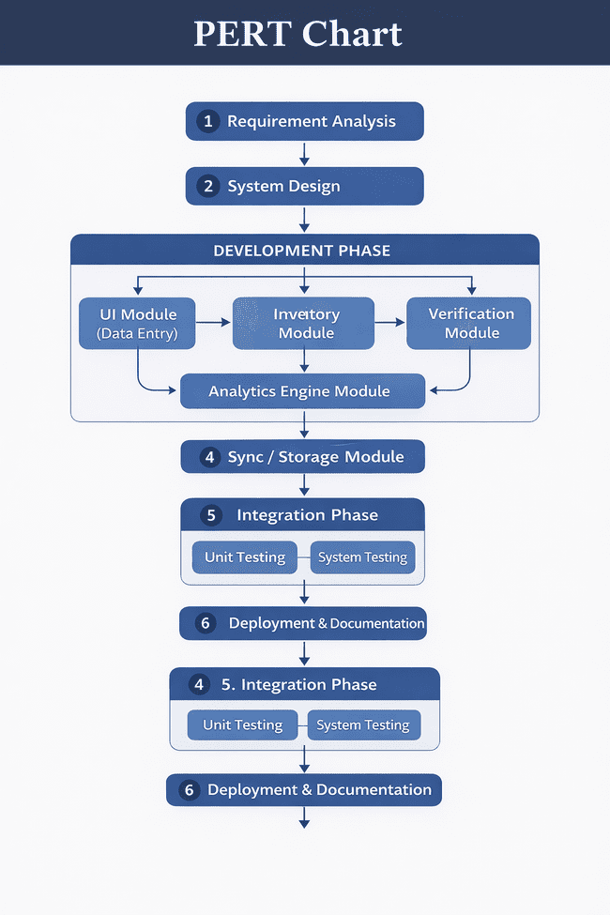
PERT Chart

Gantt Chart
The Gantt chart represents the project timeline in a time-based visual schedule. The estimated duration of each phase is:
- Requirement Analysis – 1 week
- System Design – 1 week
- Development – 3 weeks
- Integration – 2 weeks
- Testing – 2 weeks
- Documentation & Deployment – 1 week
The total estimated project duration is 10 weeks, with some overlapping of development, integration, and testing phases to optimize time utilization and ensure smooth progress.

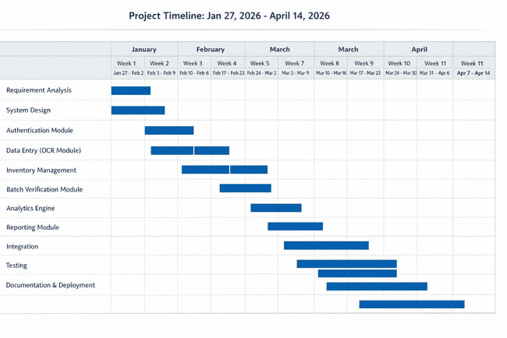

SOFTWARE REQUIREMENT SPECIFICATIONS (SRS)
The Software Requirement Specification defines the functional and non-functional requirements of the proposed mobile application to ensure proper system development, performance, and usability for small shopkeepers and local vendors. The system is designed to digitize handwritten sales records, provide meaningful business insights, and support product authenticity verification in a simple and secure manner.
Functional Requirements
The application allows users to capture images of handwritten sales records and convert them into structured digital data using OCR technology. It securely stores and manages sales, expense, and product information while enabling easy retrieval when required. The system generates daily, weekly, monthly, and yearly sales reports along with automatic profit or loss calculations. It also provides useful business insights such as identification of fast-moving and slow-moving products, stock reminders, and simple improvement suggestions. In addition, the application supports barcode or batch number scanning to verify product authenticity and detect suspicious or counterfeit items. Offline data entry is supported, and the system automatically synchronizes stored data when an internet connection becomes available.
Non-Functional Requirements
The application is designed with a simple and user-friendly interface suitable for individuals with limited digital knowledge. It ensures data security, privacy, and reliable storage with backup and recovery capabilities. The system is expected to provide fast response time, accurate OCR recognition, and stable performance on standard smartphones. Furthermore, the design allows scalability to handle increasing business data and flexibility for future feature enhancements.
The hardware requirements for operating the system are minimal and include a smartphone with camera support, sufficient storage capacity, and basic internet connectivity for synchronization. On the software side, the application is developed using Java-based mobile development technologies, integrated OCR libraries for text recognition, and secure local or cloud-based storage mechanisms for data management and analytics.

Hardware Requirements
A smartphone with camera support, minimum required storage, and basic internet connectivity for synchronization is sufficient to operate the system.

Software Requirements
The system is developed using Python-based development tools, OCR libraries for text recognition, and secure storage or cloud synchronization technologies for data management and analytics.

SOFTWARE ENGINEERING PARADIGM APPLIED
The development of the Veriscope Trade system follows the Incremental Software Development Model, which is a widely used software engineering paradigm where the system is designed, developed, and tested in small functional modules or increments. Instead of building the entire system at once, the project is developed step by step, with each increment adding new features and improvements to the system.
This approach is particularly suitable for the Veriscope Trade project because the system consists of multiple independent modules such as user authentication, shop registration, sales management, OCR-based data extraction, batch verification, and analytics. By developing the system incrementally, each module can be designed, implemented, and tested individually before integrating it with the complete system.
In the first increment, the basic system functionality is developed, including user registration, login authentication, and shop information setup. In the next increment, the sales entry module and dashboard are implemented to allow shopkeepers to record and view their daily sales data. Subsequent increments include advanced features such as OCR-based notebook scanning for automatic sales data extraction, batch number verification for identifying suspicious products, and reminder notifications for missing sales entries.
The Incremental Model provides several advantages for this project. It allows early testing of system components, reduces development risk, and enables gradual improvements based on system performance. Additionally, it makes the system easier to maintain and extend in the future, as new features such as inventory management, advanced analytics, or mobile integration can be added without redesigning the entire system.
Therefore, the Incremental Software Development Paradigm is used in this project to ensure systematic development, efficient testing, and continuous enhancement of the Veriscope Trade system.

System Model

Data Model (DFD – Data Flow Diagram)

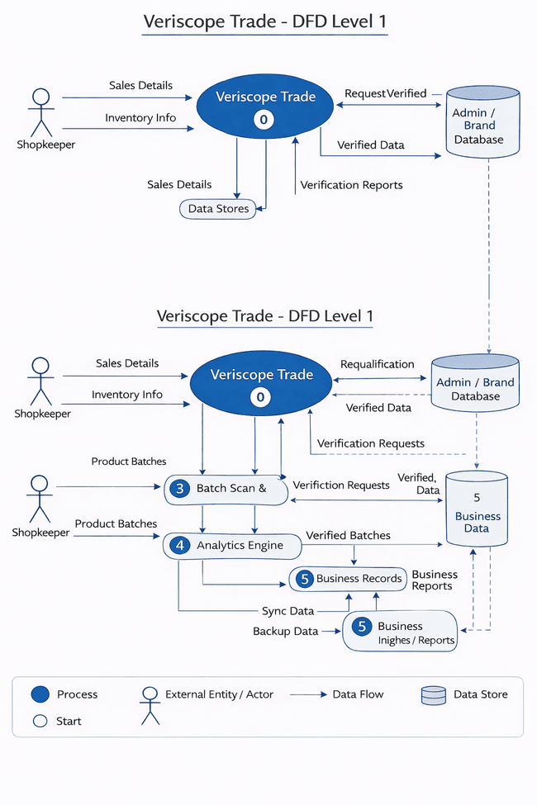

DFD Level – 0:

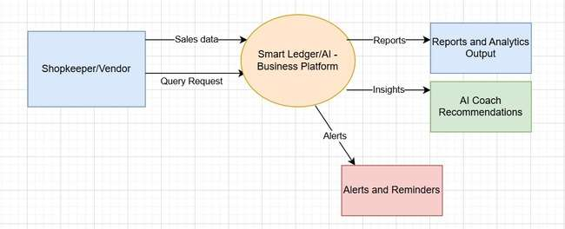
LVL-2 DFD:
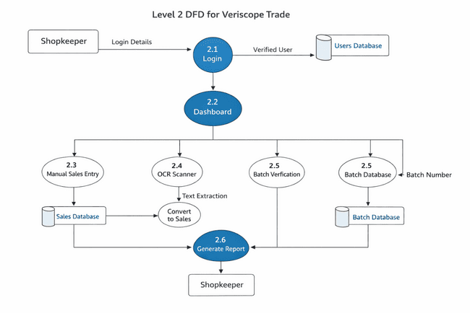

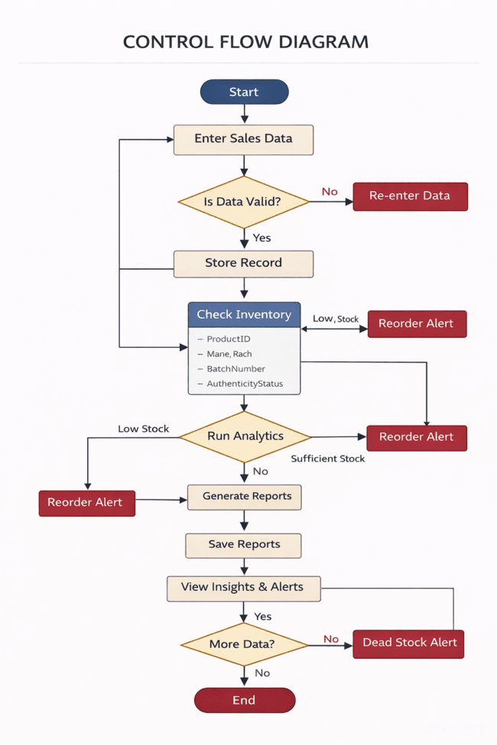
Control Flow Diagram

State Diagram
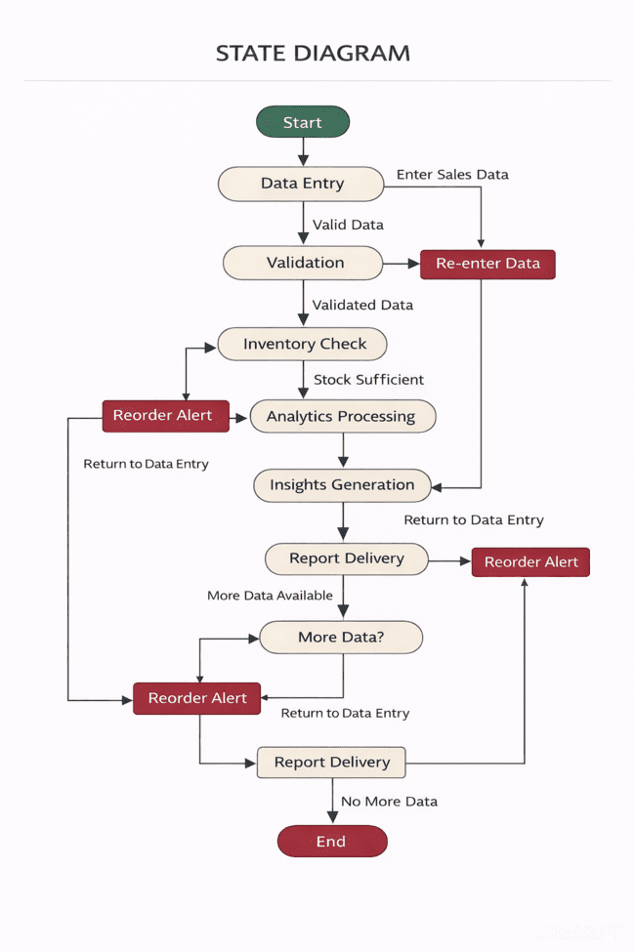

Sequence Diagram
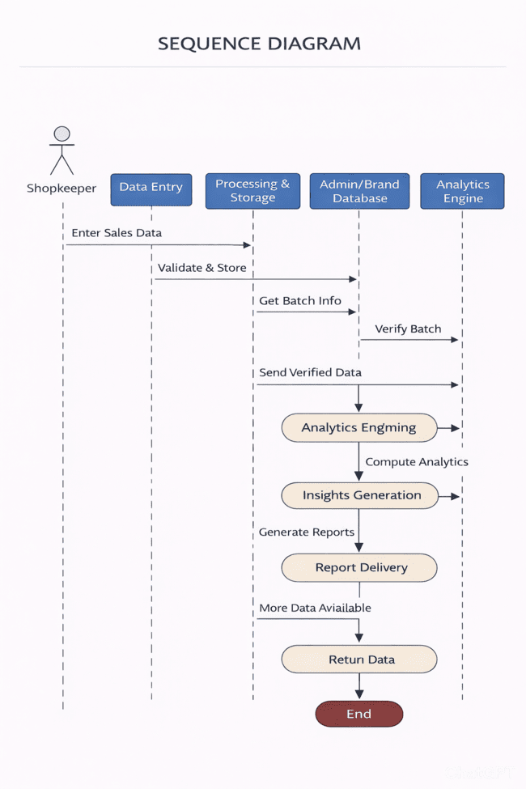

Entity–Relationship (ER) Model diagram
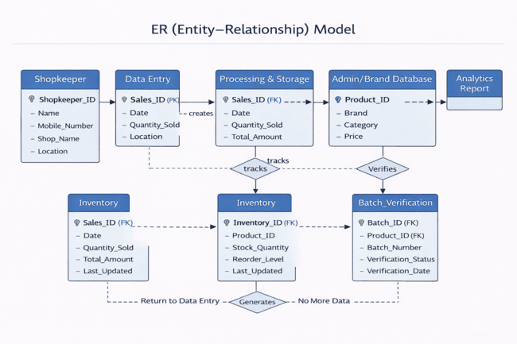

Class Diagram / CRC Model
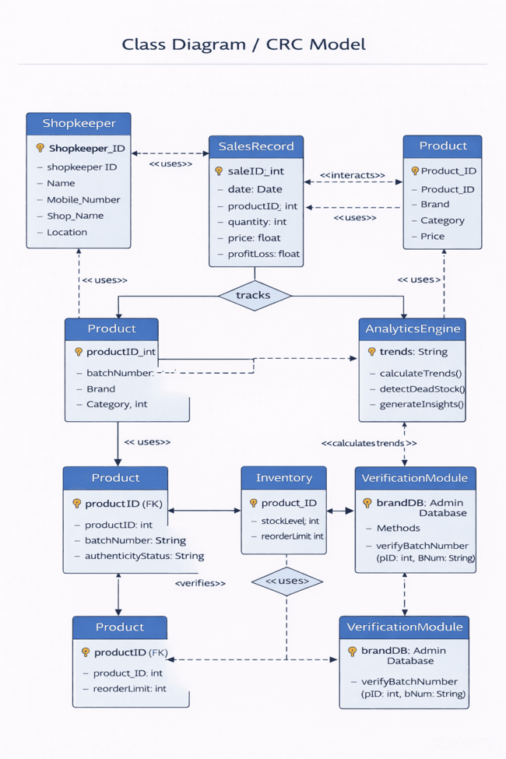

Use-Case Diagram

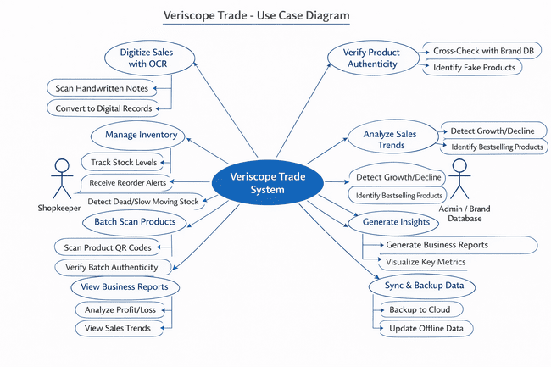

FLOWCHART
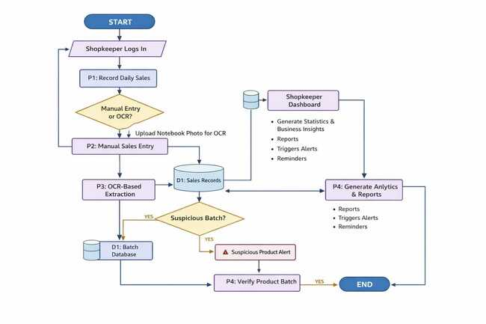
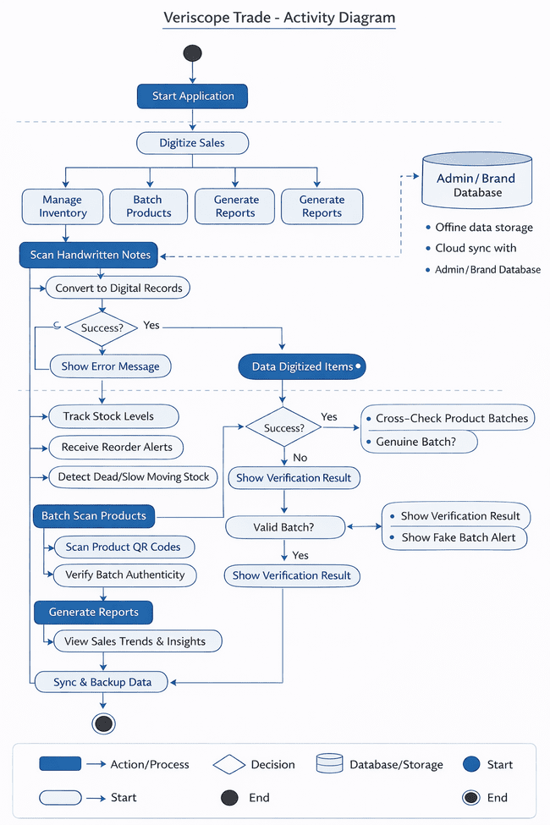
Activity Diagram

SYSTEM DESIGN
System design is an important phase in software development that focuses on defining the overall architecture, components, data flow, and interactions within the system. The Veriscope Trade system is designed using a modular, scalable, and user-friendly approach to ensure efficiency, accuracy, and reliability for small shopkeepers.

1. Modularisation Details
Modularisation refers to dividing a system into smaller, independent, and manageable modules so that each module performs a specific function. The Veriscope Trade application is divided into the following major modules:

a) Data Entry Module
This module allows shopkeepers to digitize handwritten sales records using Optical Character Recognition (OCR). It captures sales data, validates it, and converts it into digital format for storage and analysis.

b) Inventory Management Module
This module manages stock levels, tracks product availability, identifies slow-moving items, and generates reorder alerts when stock reaches a minimum threshold.

c) Batch Scan and Verification Module
This module scans product QR codes or batch numbers to verify authenticity. It communicates with the brand database to detect counterfeit products.

d) Analytics Engine Module
This module processes sales and inventory data to generate business insights such as profit/loss analysis, trend forecasting, and performance reports.

e) Reporting and Insights Module
This module provides graphical and tabular reports to shopkeepers for better decision-making.

f) Synchronization Module
This module ensures secure data backup and synchronization between local storage and cloud servers.
Each module works independently while maintaining proper communication with other modules, ensuring system reliability and scalability.

2. Data Integrity and Constraints
Data integrity ensures accuracy, consistency, and reliability of data stored in the system. The Veriscope Trade system implements the following constraints:

a) Entity Integrity
Each table has a unique primary key such as Product ID, Sales ID, or User ID to ensure that every record is uniquely identifiable.

b) Referential Integrity
Foreign keys are used to maintain relationships between tables. For example, Sales records are linked to Product records through Product ID.

c) Domain Constraints
Data types and validation rules are applied to ensure correct data entry. For instance:
- Quantity must be a positive integer.
- Price must be a numeric value.
- Dates must follow a standard format.

d) Validation Rules
Input validation ensures that incomplete or incorrect data is not stored in the system.

3. Database Design
The Veriscope Trade system uses a relational database model to store and manage data efficiently.

Main Database Tables

a) User Table
Stores shopkeeper login details and profile information.
- User_ID (Primary Key)
- Name
- Phone Number
- Password

b) Product Table
Contains product details and stock information.
- Product_ID (Primary Key)
- Product Name
- Batch Number
- Price
- Quantity

c) Sales Table
Stores digitized sales transaction records.
- Sales_ID (Primary Key)
- Product_ID (Foreign Key)
- Quantity Sold
- Date

d) Verification Table
Stores product authenticity verification results.
- Verification_ID (Primary Key)
- Product_ID
- Batch Status
- Verification Date

e) Reports Table
Stores generated business insights and analytics results.
The database is designed using normalization techniques to avoid data redundancy and improve efficiency.

4. User Interface Design
The user interface of Veriscope Trade is designed to be simple, intuitive, and user-friendly, especially for small shopkeepers who may have limited technical knowledge.

Design Principles

a) Simplicity
The interface uses clear icons, minimal text, and easy navigation to ensure usability.

b) Consistency
Uniform layout, color schemes, and menu structures are maintained throughout the application.

c) Accessibility
Large buttons, readable fonts, and simple instructions make the system accessible to all users.

Main UI Screens
- Login Screen – Secure user authentication.
- Dashboard Screen – Displays key business statistics and quick actions.
- Sales Digitization Screen – Allows scanning of handwritten records.
- Inventory Screen – Shows stock details and alerts.
- Verification Screen – Used for batch scanning and authenticity checking.
- Reports Screen – Displays charts, trends, and business insights.

Testing
Testing Techniques

1. Unit Testing
Unit testing was applied to test individual functions and modules independently.

Examples from the project:
- Password hashing function (hp())
- Database connection (db())
- OCR preprocessing (preprocess())
- OCR extraction (tesseract_ocr())

Purpose:
- Ensure each function works correctly in isolation
- Detect logical errors early
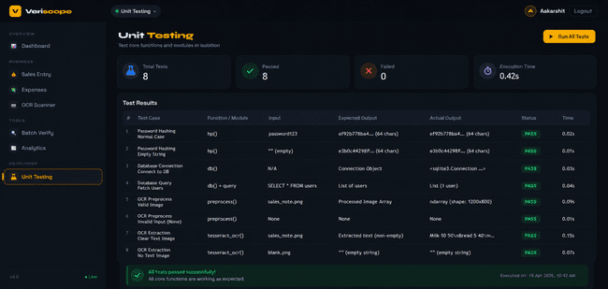

2. Integration Testing
Integration testing ensures that different modules interact correctly.

Tested Integrations:
- Frontend (HTML/JS) ↔ Flask APIs
- API ↔ SQLite Database
- OCR module ↔ Sales entry system

Example:
- OCR scanned data → parsed → inserted into sales table
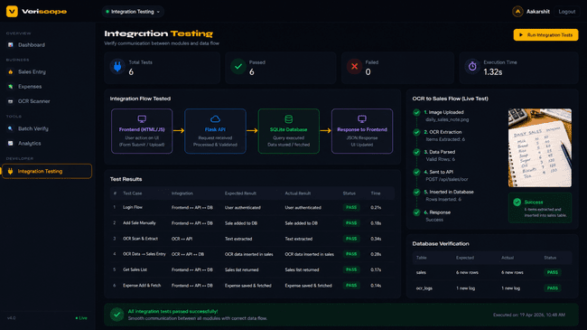

3. System Testing
Complete system testing was performed to validate the full application.

Tested Features:
- User signup/login/logout
- Sales and expense tracking
- Batch verification system
- Analytics dashboard
- OCR scanner

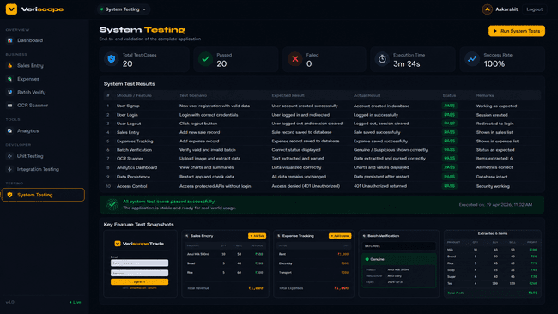

4. Functional Testing
Each feature was tested based on functional requirements.
Module | Test Case | Result
Login | Wrong credentials | Error shown
Signup | Duplicate email | Blocked
Sales Entry | Missing fields | Validation error
Batch Verify | Invalid batch | Shows “Unknown”
OCR | Image input | Extracts text

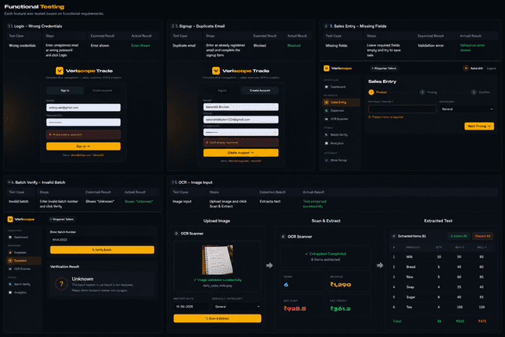

5. Boundary Value Testing
Inputs were tested at extreme values.

Examples:
- Quantity = 0
- Very large price values
- Empty input fields
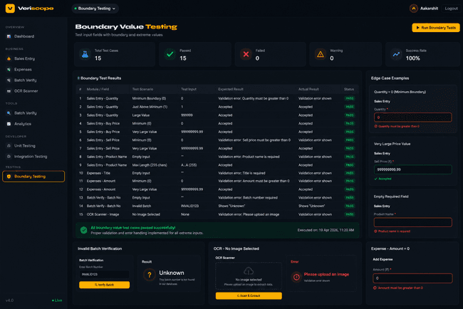

6. Performance Testing
System performance was tested for:
- Handling multiple records (500+ sales entries)
- Analytics calculations
- OCR processing time


7. User Interface (UI) Testing
Frontend UI (HTML/CSS/JS) was tested for:
- Responsiveness
- Form usability
- Navigation flow
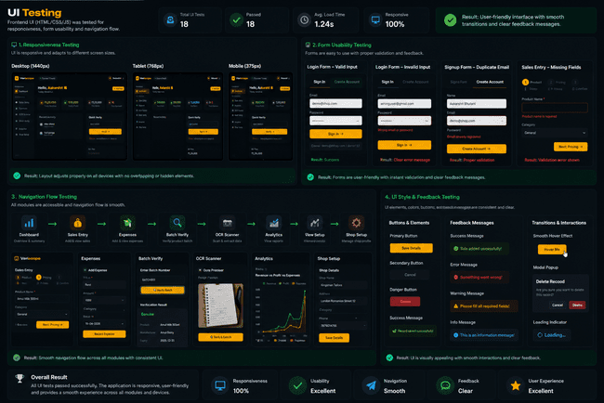

8. Error Handling Testing
The system was tested for handling runtime errors.

Examples:
- Invalid JSON input
- Database errors
- Unauthorized access

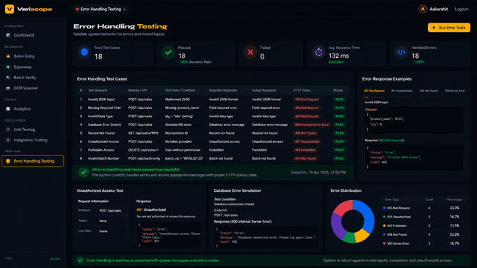

Testing Strategies

1. Authentication & Session Management
- Secure login system using Flask sessions
- Session-based authentication (session['uid'])
- Protected routes using @auth decorator

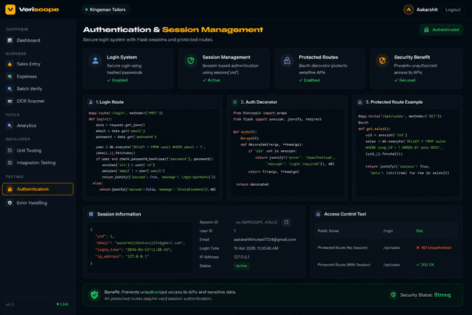

2. Password Security
- Passwords are hashed using SHA-256:
hashlib.sha256(password.encode()).hexdigest()
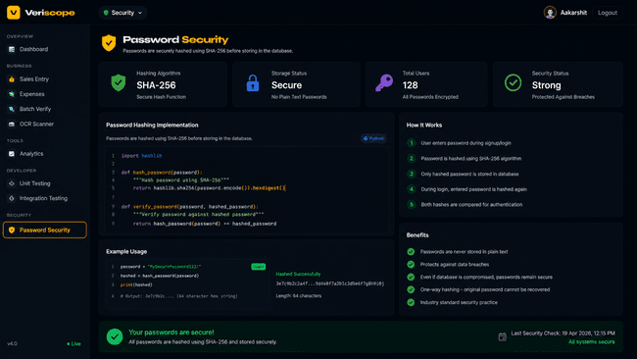

3. Input Validation & Sanitization
- Required fields are validated
- Data is cleaned before database insertion
- Type casting (float, string) ensures correctness

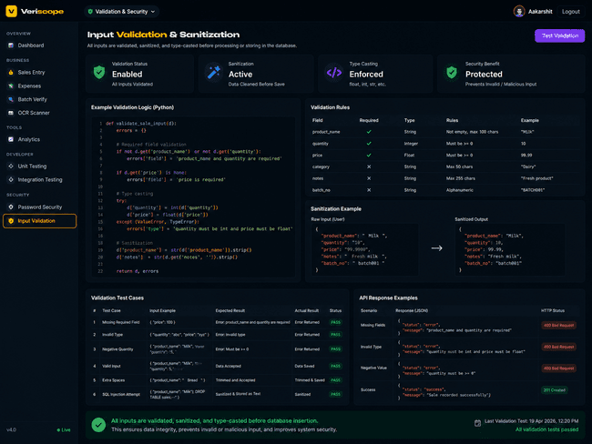

4. SQL Injection Protection
- Parameterized queries used:
con.execute('SELECT * FROM users WHERE email=?', (email,))

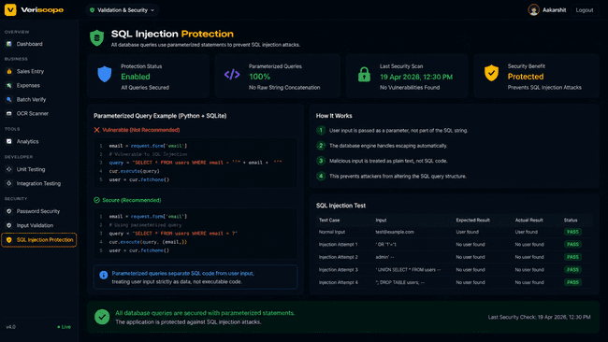

5. Data Isolation
- Each user’s data is linked using user_id

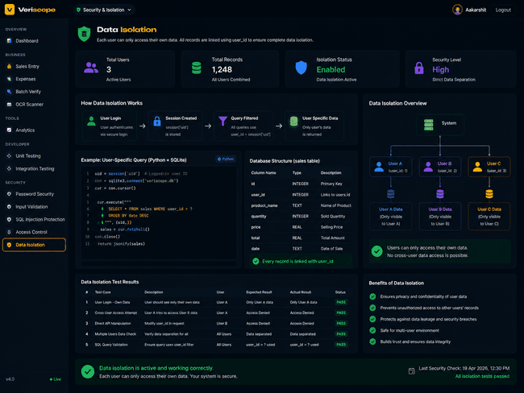

6. Data Integrity
- UNIQUE constraints in database:

UNIQUE(user_id, name)
7. Secret Key Protection

app.secret_key = 'vt2025xk9m'
8. Secure API Design
- Uses HTTP status codes:
  - 200 → Success
  - 400 → Bad request
  - 401 → Unauthorized

9. Access Control
- APIs protected using authentication decorator:
@auth

10. Secure API Design
- Uses HTTP status codes:
  - 200 → Success
  - 400 → Bad request
  - 401 → Unauthorized

System Security Measures (Implementation of Security)

1. Authentication & Session Management
- Secure login system implemented using Flask sessions
- Session-based authentication using session['uid']
- Protected routes implemented using @auth decorator

Implementation:
- Users must log in before accessing any protected API
- Each request verifies the active session

Benefit:
- Prevents unauthorized access to system resources
- Ensures only authenticated users can use the application

2. Password Security (Hashing)
- Passwords are securely stored using SHA-256 hashing

Implementation:
hashlib.sha256(password.encode()).hexdigest()

Benefit:
- Passwords are not stored in plain text
- Protects user data even if the database is compromised

3. Input Validation & Sanitization
- All user inputs are validated before processing
- Data is cleaned before storing in the database
- Type casting (float, string) ensures correct format

Example:
if not d.get('product_name') or not d.get('quantity'):

Benefit:
- Prevents invalid data entry
- Protects against malicious input

4. SQL Injection Protection
- Uses parameterized queries instead of raw SQL queries

Implementation:
con.execute('SELECT * FROM users WHERE email=?', (email,))

Benefit:
- Prevents SQL injection attacks
- Ensures safe interaction with the database

5. Access Control Mechanism
- APIs are protected using authentication checks
- Unauthorized users receive proper error responses

Implementation:
- Protected routes require valid session
- Unauthorized access returns HTTP 401

Benefit:
- Secures sensitive APIs
- Ensures proper user authorization

6. Data Isolation (User-wise Security)
- Each user’s data is linked using user_id
- Queries filter data based on logged-in user

Benefit:
- Users cannot access other users’ data
- Maintains privacy and data security

7. Error Handling & Secure Responses
- System handles runtime errors effectively
- Proper HTTP status codes are returned

Examples:
- 400 → Bad Request
- 401 → Unauthorized

Benefit:
- Prevents system crashes
- Provides clear feedback to users

8. Secure OCR Processing
- OCR processes only uploaded image files
- No execution of user-provided scripts

Benefit:
- Prevents malicious file execution
- Ensures safe data extraction

9. Secret Key Protection
- Flask application uses a secret key:
app.secret_key = 'your_secret_key'

Benefit:
- Protects session data
- Prevents session tampering

10. Data Integrity & Constraints
- Database constraints applied:
  - UNIQUE constraints
  - Required fields

Example:
UNIQUE(user_id, name)

REPORTS
1.Sales Report
Includes daily transactions with product details, quantity, selling price, and total revenue.
2.Profit & Loss Report
Calculates profit or loss based on buying and selling prices.
3.Revenue & Net Profit Report
Shows total income and final profit after deducting expenses.
4.Expense Report
Records all business expenses such as rent, electricity, and other costs.
5.Product & Category-wise Report
Analyzes performance of individual products and different categories.
6.Payment Mode & Batch Verification Report
Tracks payment methods (Cash, UPI, etc.) and verifies product authenticity.
7.OCR & Analytics Report
Displays OCR-extracted data using Tesseract OCR and visual insights using Chart.js.
8.All-Time Summary Report
Provides an overall view of total sales, total revenue, total expenses, and overall business performance across the entire period.

FUTURE SCOPE AND FURTHER ENHANCEMENTS
The Veriscope Trade system has significant potential for future development.

1. AI-Based Demand Prediction
Future versions can use machine learning to predict sales demand.

2. Mobile Payment Integration
Integration with digital payment systems can be added.

3. Multi-User Support
Multiple shop staff can access the system simultaneously.

4. Real-Time Cloud Analytics
Advanced cloud-based analytics can improve decision-making.

5. Voice Input Support
Voice recognition can help less literate users.

6. Barcode Auto-Billing System
Automatic billing features can be integrated.
7. Enhanced Security
Implement data encryption, authentication layers, and secure APIs.
8.GST Billing & Invoice Generation
Add proper billing system with GST calculations and printable invoices.

Appendices
Coding
from flask import Flask, render_template, request, jsonify, session
import sqlite3, os, re, hashlib, io
from datetime import date, timedelta
from collections import defaultdict
from functools import wraps
import pytesseract

# Path to the Tesseract executable (Windows)
pytesseract.pytesseract.tesseract_cmd = r"C:\Program Files\Tesseract-OCR\tesseract.exe"

app = Flask(__name__)
app.secret_key = 'vt2025xk9m'
DB = os.path.join(os.path.dirname(os.path.abspath(__file__)), 'shop.db')

def db():
c = sqlite3.connect(DB)
c.row_factory = sqlite3.Row
return c

def init_db():
con = db()
con.executescript('''
CREATE TABLE IF NOT EXISTS users (
id INTEGER PRIMARY KEY AUTOINCREMENT,
name TEXT NOT NULL, email TEXT UNIQUE NOT NULL, password TEXT NOT NULL,
shop_name TEXT DEFAULT '', shop_address TEXT DEFAULT '',
shop_category TEXT DEFAULT 'General', phone TEXT DEFAULT '',
created_at TEXT DEFAULT (date('now'))
);
CREATE TABLE IF NOT EXISTS sales (
id INTEGER PRIMARY KEY AUTOINCREMENT, user_id INTEGER NOT NULL,
product_name TEXT NOT NULL, category TEXT DEFAULT 'General',
quantity REAL NOT NULL, buying_price REAL DEFAULT 0, selling_price REAL NOT NULL,
date TEXT NOT NULL, payment_mode TEXT DEFAULT 'Cash',
customer TEXT DEFAULT '', note TEXT DEFAULT '',
created_at TEXT DEFAULT (datetime('now'))
);
CREATE TABLE IF NOT EXISTS expenses (
id INTEGER PRIMARY KEY AUTOINCREMENT, user_id INTEGER NOT NULL,
title TEXT NOT NULL, amount REAL NOT NULL, category TEXT DEFAULT 'General',
date TEXT NOT NULL, note TEXT DEFAULT '',
created_at TEXT DEFAULT (datetime('now'))
);
CREATE TABLE IF NOT EXISTS products (
id INTEGER PRIMARY KEY AUTOINCREMENT, user_id INTEGER NOT NULL,
name TEXT NOT NULL, category TEXT DEFAULT 'General',
buy_price REAL DEFAULT 0, sell_price REAL DEFAULT 0,
stock REAL DEFAULT 0, unit TEXT DEFAULT 'pcs',
UNIQUE(user_id, name)
);
CREATE TABLE IF NOT EXISTS batches (
batch_no TEXT PRIMARY KEY, product TEXT, manufacturer TEXT, expiry TEXT, status TEXT
);
CREATE TABLE IF NOT EXISTS batch_checks (
id INTEGER PRIMARY KEY AUTOINCREMENT, user_id INTEGER,
batch_no TEXT, status TEXT, checked_at TEXT DEFAULT (datetime('now'))
);
''')
for b in [
('BATCH001','Amul Milk 500ml','Amul Dairy','2025-12-31','Genuine'),
('BATCH002','Britannia Bread','Britannia','2025-08-15','Genuine'),
('BATCH003','SOAP-XYZ-FAKE','Unknown','N/A','Suspicious'),
('BATCH004','India Gate Rice 5kg','KRBL','2026-03-01','Genuine'),
('BATCH005','OIL-COUNTERFEIT','Unknown','N/A','Suspicious'),
('BATCH006','Tata Salt 1kg','Tata Consumer','2026-06-30','Genuine'),
('BATCH007','TEA-REPLICATED','Unknown','N/A','Suspicious'),
('BATCH008','Nescafe 200g','Nestle India','2025-11-30','Genuine'),
('BATCH009','Fortune Oil 1L','Adani Wilmar','2025-09-20','Genuine'),
('BATCH010','MDH-ADULTERATED','Unknown','N/A','Suspicious'),
('BATCH011','Parle-G 1kg','Parle Products','2025-10-10','Genuine'),
('BATCH012','Surf Excel 1kg','HUL','2026-01-15','Genuine'),
]:
con.execute('INSERT OR IGNORE INTO batches VALUES (?,?,?,?,?)', b)
try:
con.execute("INSERT OR IGNORE INTO users (name,email,password,shop_name) VALUES (?,?,?,?)",
('Demo User','demo@shop.com', hashlib.sha256(b'demo123').hexdigest(),'Demo Shop'))
except: pass
con.commit(); con.close()

def hp(pw): return hashlib.sha256(pw.encode()).hexdigest()
def uid(): return session['uid']
def auth(f):
@wraps(f)
def w(*a,**k):
if 'uid' not in session: return jsonify({'error':'Unauthorized'}),401
return f(*a,**k)
return w

@app.route('/')
def index(): return render_template('index.html')

@app.route('/api/me')
def me():
if 'uid' not in session: return jsonify({'ok':False})
con=db(); u=con.execute('SELECT * FROM users WHERE id=?',(session['uid'],)).fetchone(); con.close()
return jsonify({'ok':True,'user':dict(u)}) if u else jsonify({'ok':False})

@app.route('/api/login',methods=['POST'])
def login():
d=request.json or {}
con=db(); u=con.execute('SELECT * FROM users WHERE email=? AND password=?',(d.get('email','').lower(),hp(d.get('password','')))).fetchone(); con.close()
if not u: return jsonify({'error':'Wrong email or password'}),401
session['uid']=u['id']; return jsonify({'ok':True,'user':dict(u)})

@app.route('/api/signup',methods=['POST'])
def signup():
d=request.json or {}
nm=d.get('name','').strip(); em=d.get('email','').strip().lower(); pw=d.get('password','')
if not nm or not em or not pw: return jsonify({'error':'All fields required'}),400
if len(pw)<6: return jsonify({'error':'Password min 6 chars'}),400
con=db()
try:
con.execute('INSERT INTO users (name,email,password) VALUES (?,?,?)',(nm,em,hp(pw))); con.commit()
u=con.execute('SELECT * FROM users WHERE email=?',(em,)).fetchone()
session['uid']=u['id']; return jsonify({'ok':True,'user':dict(u)})
except sqlite3.IntegrityError: return jsonify({'error':'Email already registered'}),400
finally: con.close()

@app.route('/api/logout',methods=['POST'])
def logout(): session.clear(); return jsonify({'ok':True})

@app.route('/api/shop',methods=['POST'])
@auth
def save_shop():
d=request.json or {}; con=db()
con.execute('UPDATE users SET shop_name=?,shop_address=?,shop_category=?,phone=? WHERE id=?',
(d.get('shop_name',''),d.get('shop_address',''),d.get('shop_category','General'),d.get('phone',''),uid()))
con.commit(); u=con.execute('SELECT * FROM users WHERE id=?',(uid(),)).fetchone(); con.close()
return jsonify({'ok':True,'user':dict(u)})

@app.route('/api/sales',methods=['GET'])
@auth
def get_sales():
q=request.args.get('q',''); con=db()
if q: rows=con.execute("SELECT * FROM sales WHERE user_id=? AND product_name LIKE ? ORDER BY date DESC,id DESC LIMIT 500",(uid(),f'%{q}%')).fetchall()
else: rows=con.execute("SELECT * FROM sales WHERE user_id=? ORDER BY date DESC,id DESC LIMIT 500",(uid(),)).fetchall()
con.close(); return jsonify([dict(r) for r in rows])

@app.route('/api/sales',methods=['POST'])
@auth
def add_sale():
d=request.json or {}
if not d.get('product_name') or not d.get('quantity') or d.get('selling_price') is None:
return jsonify({'error':'Missing fields'}),400
con=db()
cur=con.execute('INSERT INTO sales (user_id,product_name,category,quantity,buying_price,selling_price,date,payment_mode,customer,note) VALUES (?,?,?,?,?,?,?,?,?,?)',
(uid(),str(d['product_name']).strip(),d.get('category','General'),float(d['quantity']),
float(d.get('buying_price',0)),float(d['selling_price']),d.get('date',str(date.today())),
d.get('payment_mode','Cash'),d.get('customer',''),d.get('note','')))
con.commit()
try:
con.execute('INSERT INTO products (user_id,name,category,buy_price,sell_price) VALUES (?,?,?,?,?) ON CONFLICT(user_id,name) DO UPDATE SET buy_price=excluded.buy_price,sell_price=excluded.sell_price,category=excluded.category',
(uid(),str(d['product_name']).strip(),d.get('category','General'),float(d.get('buying_price',0)),float(d['selling_price'])))
con.commit()
except: pass
sale=con.execute('SELECT * FROM sales WHERE id=?',(cur.lastrowid,)).fetchone(); con.close()
return jsonify({'ok':True,'sale':dict(sale)})

@app.route('/api/sales/<int:sid>',methods=['PUT'])
@auth
def update_sale(sid):
d=request.json or {}; con=db()
con.execute('UPDATE sales SET product_name=?,category=?,quantity=?,buying_price=?,selling_price=?,date=?,payment_mode=?,note=? WHERE id=? AND user_id=?',
(d.get('product_name'),d.get('category','General'),float(d.get('quantity',0)),float(d.get('buying_price',0)),float(d.get('selling_price',0)),d.get('date'),d.get('payment_mode','Cash'),d.get('note',''),sid,uid()))
con.commit(); con.close(); return jsonify({'ok':True})

@app.route('/api/sales/<int:sid>',methods=['DELETE'])
@auth
def del_sale(sid):
con=db(); con.execute('DELETE FROM sales WHERE id=? AND user_id=?',(sid,uid())); con.commit(); con.close()
return jsonify({'ok':True})

@app.route('/api/expenses',methods=['GET'])
@auth
def get_expenses():
con=db(); rows=con.execute('SELECT * FROM expenses WHERE user_id=? ORDER BY date DESC,id DESC LIMIT 200',(uid(),)).fetchall(); con.close()
return jsonify([dict(r) for r in rows])

@app.route('/api/expenses',methods=['POST'])
@auth
def add_expense():
d=request.json or {}
if not d.get('title') or not d.get('amount'): return jsonify({'error':'Title and amount required'}),400
con=db()
cur=con.execute('INSERT INTO expenses (user_id,title,amount,category,date,note) VALUES (?,?,?,?,?,?)',
(uid(),d['title'].strip(),float(d['amount']),d.get('category','General'),d.get('date',str(date.today())),d.get('note','')))
con.commit(); e=con.execute('SELECT * FROM expenses WHERE id=?',(cur.lastrowid,)).fetchone(); con.close()
return jsonify({'ok':True,'expense':dict(e)})

@app.route('/api/expenses/<int:eid>',methods=['DELETE'])
@auth
def del_expense(eid):
con=db(); con.execute('DELETE FROM expenses WHERE id=? AND user_id=?',(eid,uid())); con.commit(); con.close()
return jsonify({'ok':True})

@app.route('/api/products',methods=['GET'])
@auth
def get_products():
con=db(); rows=con.execute('SELECT * FROM products WHERE user_id=? ORDER BY name',(uid(),)).fetchall(); con.close()
return jsonify([dict(r) for r in rows])

@app.route('/api/analytics')
@auth
def analytics():
con=db()
sales=[dict(r) for r in con.execute('SELECT * FROM sales WHERE user_id=?',(uid(),)).fetchall()]
exps=[dict(r) for r in con.execute('SELECT * FROM expenses WHERE user_id=?',(uid(),)).fetchall()]
con.close()
today_s=str(date.today()); this_m=today_s[:7]
last_m=str((date.today().replace(day=1)-timedelta(days=1)))[:7]
def rev(r): return sum(x['selling_price']*x['quantity'] for x in r)
def cost(r): return sum(x['buying_price']*x['quantity'] for x in r)
def prof(r): return rev(r)-cost(r)
tod=[r for r in sales if r['date']==today_s]
this_ms=[r for r in sales if r['date'].startswith(this_m)]
last_ms=[r for r in sales if r['date'].startswith(last_m)]
tr=rev(sales); tp=prof(sales); te=sum(e['amount'] for e in exps)
g=(rev(this_ms)-rev(last_ms))/rev(last_ms)*100 if rev(last_ms)>0 else 0
daily=defaultdict(lambda:{'rev':0.0,'prof':0.0,'cnt':0,'exp':0.0})
for r in sales:
daily[r['date']]['rev']+=r['selling_price']*r['quantity']
daily[r['date']]['prof']+=(r['selling_price']-r['buying_price'])*r['quantity']
daily[r['date']]['cnt']+=1
for e in exps: daily[e['date']]['exp']+=e['amount']
trend=[{'date':str(date.today()-timedelta(days=i)),'rev':round(daily[str(date.today()-timedelta(days=i))]['rev'],2),'prof':round(daily[str(date.today()-timedelta(days=i))]['prof'],2),'exp':round(daily[str(date.today()-timedelta(days=i))]['exp'],2)} for i in range(29,-1,-1)]
prods=defaultdict(lambda:{'rev':0.0,'prof':0.0,'qty':0.0})
for r in sales:
prods[r['product_name']]['rev']+=r['selling_price']*r['quantity']
prods[r['product_name']]['prof']+=(r['selling_price']-r['buying_price'])*r['quantity']
prods[r['product_name']]['qty']+=r['quantity']
cats=defaultdict(float)
for r in sales: cats[r.get('category','General')]+=r['selling_price']*r['quantity']
pays=defaultdict(float)
for r in sales: pays[r.get('payment_mode','Cash')]+=r['selling_price']*r['quantity']
ad=len(set(r['date'] for r in sales)) or 1
return jsonify({'total_rev':round(tr,2),'total_prof':round(tp,2),'total_exp':round(te,2),'net_profit':round(tp-te,2),'today_rev':round(rev(tod),2),'today_prof':round(prof(tod),2),'today_cnt':len(tod),'total_cnt':len(sales),'this_month_rev':round(rev(this_ms),2),'growth':round(g,1),'margin':round(tp/tr*100,1) if tr>0 else 0,'avg_daily':round(tr/ad,2),'today_recorded':len(tod)>0,'trend':trend,'products':{k:{kk:round(vv,2) if isinstance(vv,float) else vv for kk,vv in v.items()} for k,v in prods.items()},'categories':dict(cats),'payments':dict(pays),'today_exp':round(sum(e['amount'] for e in exps if e['date']==today_s),2)})

@app.route('/api/batch',methods=['POST'])
@auth
def verify_batch():
bn=(request.json or {}).get('batch_no','').strip().upper()
if not bn: return jsonify({'error':'Required'}),400
con=db(); row=con.execute('SELECT * FROM batches WHERE batch_no=?',(bn,)).fetchone()
status=row['status'] if row else 'Unknown'
con.execute('INSERT INTO batch_checks (user_id,batch_no,status) VALUES (?,?,?)',(uid(),bn,status))
con.commit(); con.close()
return jsonify({'found':bool(row),**(dict(row) if row else {'batch_no':bn,'status':'Unknown','product':None})})

@app.route('/api/batch-history')
@auth
def batch_hist():
con=db(); rows=con.execute('SELECT * FROM batch_checks WHERE user_id=? ORDER BY checked_at DESC LIMIT 20',(uid(),)).fetchall(); con.close()
return jsonify([dict(r) for r in rows])

# ─── REAL OCR WITH TESSERACT ──────────────────────────────────────────────
def preprocess(img):
from PIL import Image, ImageEnhance, ImageFilter, ImageOps
img = img.convert('RGB')
w,h = img.size
if max(w,h) < 1400:
s = 1400/max(w,h)
img = img.resize((int(w*s),int(h*s)), Image.LANCZOS)
g = img.convert('L')
g = ImageEnhance.Contrast(g).enhance(2.5)
g = ImageEnhance.Sharpness(g).enhance(2.0)
g = g.filter(ImageFilter.GaussianBlur(0.6))
hist = g.histogram(); total = sum(hist); cum = 0; thresh = 128
for i,c in enumerate(hist):
cum += c
if cum >= total*0.45: thresh=i; break
thresh = max(90, min(thresh, 210))
b = g.point(lambda p: 255 if p > thresh else 0,'1').convert('L')
b = b.filter(ImageFilter.MaxFilter(3))
avg = sum(b.getdata())/len(b.getdata())
if avg < 127: b = ImageOps.invert(b)
return b

def tesseract_ocr(img):
import pytesseract
processed = preprocess(img)
best = ('', 0)
for psm in [6, 4, 3, 11]:
try:
raw = pytesseract.image_to_string(processed, config=f'--oem 3 --psm {psm}', lang='eng')
score = sum(1 for l in raw.splitlines() if re.search(r'[a-zA-Z]',l) and re.search(r'\d',l))
if score > best[1]: best = (raw, score)
except: pass
# also try rotations if low score
if best[1] < 2:
for angle in [90,-90,180]:
try:
rot = img.rotate(angle, expand=True)
p2 = preprocess(rot)
raw = pytesseract.image_to_string(p2, config='--oem 3 --psm 6', lang='eng')
score = sum(1 for l in raw.splitlines() if re.search(r'[a-zA-Z]',l) and re.search(r'\d',l))
if score > best[1]: best = (raw, score)
except: pass
return best[0]

def parse_lines(text):
SKIP = re.compile(r'^(product|item|sl|s\.?no|no\.?|date|total|qty|quantity|price|rate|rs\.?|inr|mrp|sub|grand|bill|invoice|shop|receipt|page|#)',re.I)
FIX = {ord('O'):'0',ord('l'):'1',ord('I'):'1',ord('S'):'5',ord('B'):'8',ord('G'):'6',ord(','):'.'}
def num(s):
s = re.sub(r'[^\d.,OlISBG]','',s).translate(FIX)
try: return round(float(s),2) if s else None
except: return None
results=[]; seen=set()
for line in text.splitlines():
line = line.strip()
if not line: continue
stripped = re.sub(r'^[\d\s\.\)\-]+','',line).strip()
if SKIP.match(stripped): continue
clean = re.sub(r'^\d{1,3}[\.\)\s]+','',line).strip()
clean = re.sub(r'[|,\t]',' ',clean)
clean = re.sub(r'[₹Rs\.INR]','',clean,flags=re.I)
nums = [num(m) for m in re.findall(r'\b\d+(?:[.,]\d+)?\b', clean)]
nums = [n for n in nums if n and n > 0]
if len(nums) < 2: continue
nm = re.match(r'^([^\d₹]+)', clean)
if not nm: continue
name = re.sub(r'[-:\.]+$','',nm.group(1)).strip()
name = re.sub(r'\s*(pcs?|nos?|units?|kgs?|ltrs?|ml|gm?s?|kg|ltr|pack)\.?\s*$','',name,flags=re.I).strip()
name = re.sub(r'\s{2,}',' ',name).strip()
if len(name)<2 or not re.search(r'[a-zA-Z]',name): continue
working = nums[:]
if len(working)>=3 and working[0]==int(working[0]) and 1<=working[0]<=200: working=working[1:]
if len(working)<2: continue
qty,price = working[0],working[1]
if qty<=0 or qty>99999 or price<=0 or price>999999: continue
key=name.lower()
if key in seen: continue
seen.add(key)
results.append({'product_name':name,'quantity':qty,'selling_price':price,'buying_price':round(price*0.72,2),'category':'General'})
return results

@app.route('/api/ocr',methods=['POST'])
@auth
def ocr():
text = request.form.get('text','').strip()
source = 'text'; err = None
if 'file' in request.files:
raw = request.files['file'].read()
if raw:
source = 'image'
try:
from PIL import Image
pil = Image.open(io.BytesIO(raw)); pil.load()
text = tesseract_ocr(pil)
except Exception as e: err = str(e)
parsed = parse_lines(text)
return jsonify({'ok':True,'parsed':parsed,'raw':text,'count':len(parsed),'source':source,'error':err})

if __name__ == '__main__':
os.chdir(os.path.dirname(os.path.abspath(__file__)))
init_db()
print('\n Veriscope Trade v4 | http://localhost:5050')
print(' Demo: demo@shop.com / demo123\n')
app.run(debug=True, port=5050, use_reloader=False)

<!DOCTYPE html>
<html lang="en">
<head>
<meta charset="UTF-8">
<meta name="viewport" content="width=device-width,initial-scale=1.0">
<title>Veriscope Trade</title>
<link href="https://fonts.googleapis.com/css2?family=Syne:wght@400;600;700;800&family=Space+Grotesk:wght@300;400;500;600;700&family=JetBrains+Mono:wght@400;600&display=swap" rel="stylesheet">
<script src="https://cdnjs.cloudflare.com/ajax/libs/Chart.js/4.4.0/chart.umd.min.js"></script>
<style>
:root{
--bg:#080a0f;--s1:#0e1018;--s2:#151821;--s3:#1c202e;
--b1:rgba(255,255,255,.05);--b2:rgba(255,255,255,.1);--b3:rgba(255,255,255,.17);
--gold:#f0a500;--gd:rgba(240,165,0,.12);--gg:rgba(240,165,0,.28);
--grn:#10b981;--grd:rgba(16,185,129,.11);
--red:#f43f5e;--rdd:rgba(244,63,94,.11);
--sky:#38bdf8;--skd:rgba(56,189,248,.11);
--pur:#818cf8;--prd:rgba(129,140,248,.11);
--t1:#e8ecf4;--t2:#7d859a;--t3:#40485c;
--df:'Syne',sans-serif;--bf:'Space Grotesk',sans-serif;--mf:'JetBrains Mono',monospace;
--r:8px;--r2:12px;--r3:16px;--sh:0 8px 32px rgba(0,0,0,.6);
--sw:220px;--th:56px;
}
*,*::before,*::after{box-sizing:border-box;margin:0;padding:0}
html{font-size:15px}
body{background:var(--bg);color:var(--t1);font-family:var(--bf);-webkit-font-smoothing:antialiased}
::-webkit-scrollbar{width:4px;height:4px}::-webkit-scrollbar-thumb{background:var(--b2);border-radius:10px}
input,select,textarea,button{font-family:var(--bf)}

@keyframes up{from{opacity:0;transform:translateY(16px)}to{opacity:1;transform:translateY(0)}}
@keyframes in{from{opacity:0}to{opacity:1}}
@keyframes pulse{0%,100%{opacity:1}50%{opacity:.25}}
@keyframes scan{0%,100%{top:6%}50%{top:90%}}

/* AUTH */
#auth{position:fixed;inset:0;z-index:999;display:flex;align-items:center;justify-content:center;
background:radial-gradient(ellipse 70% 50% at 15% 50%,rgba(240,165,0,.08),transparent 60%),
radial-gradient(ellipse 50% 70% at 85% 20%,rgba(56,189,248,.05),transparent 60%),var(--bg)}
.ab{width:420px;animation:up .5s ease}
.al{display:flex;align-items:center;gap:11px;justify-content:center;margin-bottom:8px}
.al-i{width:38px;height:38px;background:var(--gold);border-radius:10px;display:grid;place-items:center;font-size:18px;font-weight:900;color:#000;font-family:var(--df)}
.al-t{font-size:20px;font-weight:800;font-family:var(--df);letter-spacing:-.5px}
.al-t span{color:var(--gold)}
.a-sub{text-align:center;font-size:12px;color:var(--t3);margin-bottom:22px;letter-spacing:.3px}
.a-card{background:var(--s1);border:1px solid var(--b2);border-radius:var(--r3);padding:28px;box-shadow:0 32px 80px rgba(0,0,0,.6)}
.atabs{display:flex;background:var(--bg);border:1px solid var(--b1);border-radius:var(--r);padding:4px;gap:3px;margin-bottom:20px}
.atab{flex:1;padding:8px;border:none;border-radius:6px;background:transparent;color:var(--t3);font-size:13px;font-weight:600;cursor:pointer;transition:all .15s;font-family:var(--bf)}
.atab.on{background:var(--s2);color:var(--t1)}
.fg{margin-bottom:13px}
.fl{display:block;font-size:11px;font-weight:700;color:var(--t3);text-transform:uppercase;letter-spacing:.8px;margin-bottom:5px}
.fi{width:100%;padding:10px 13px;background:var(--bg);border:1px solid var(--b2);border-radius:var(--r);color:var(--t1);font-size:13px;outline:none;transition:all .2s;font-family:var(--bf)}
.fi:focus{border-color:var(--gold);box-shadow:0 0 0 3px var(--gd)}.fi::placeholder{color:var(--t3)}
.aerr{padding:9px 12px;background:var(--rdd);border:1px solid rgba(244,63,94,.25);border-radius:var(--r);color:var(--red);font-size:12px;margin-bottom:10px;display:none}
.abtn{width:100%;padding:12px;background:var(--gold);border:none;border-radius:var(--r);color:#000;font-size:14px;font-weight:800;cursor:pointer;transition:all .2s;letter-spacing:.2px;font-family:var(--df)}
.abtn:hover{filter:brightness(1.1);transform:translateY(-1px);box-shadow:0 6px 20px var(--gg)}
.dn{text-align:center;font-size:11px;color:var(--t3);margin-top:12px}
.dn code{background:var(--s2);padding:1px 6px;border-radius:4px;color:var(--gold);font-family:var(--mf);font-size:10px}

/* APP SHELL */
#app{display:none;min-height:100vh}
.tb{position:fixed;top:0;left:0;right:0;height:var(--th);background:rgba(8,10,15,.94);backdrop-filter:blur(20px);border-bottom:1px solid var(--b1);display:flex;align-items:center;padding:0 16px;z-index:200;gap:10px}
.tb-logo{display:flex;align-items:center;gap:9px;width:var(--sw);flex-shrink:0}
.tb-logo-i{width:28px;height:28px;background:var(--gold);border-radius:7px;display:grid;place-items:center;font-size:13px;color:#000;font-weight:900;font-family:var(--df)}
.tb-logo-t{font-size:14px;font-weight:800;font-family:var(--df);letter-spacing:-.3px}
.tb-logo-t span{color:var(--gold)}
.tb-shop{display:flex;align-items:center;gap:6px;background:var(--s2);border:1px solid var(--b2);border-radius:30px;padding:5px 12px 5px 8px;font-size:12px;font-weight:500;max-width:190px;overflow:hidden;text-overflow:ellipsis;white-space:nowrap}
.led{width:6px;height:6px;border-radius:50%;background:var(--grn);box-shadow:0 0 8px var(--grn);flex-shrink:0}
.tb-r{margin-left:auto;display:flex;align-items:center;gap:8px}
.remind{display:none;align-items:center;gap:5px;background:var(--gd);border:1px solid var(--gg);border-radius:30px;padding:4px 12px;font-size:12px;font-weight:600;color:var(--gold);cursor:pointer}
.uav{width:28px;height:28px;border-radius:50%;background:var(--gd);border:2px solid rgba(240,165,0,.3);display:grid;place-items:center;font-size:11px;font-weight:800;color:var(--gold);font-family:var(--df)}
.uname{font-size:13px;font-weight:600}
.b-out{padding:5px 11px;background:transparent;border:1px solid var(--b2);border-radius:var(--r);color:var(--t2);font-size:12px;font-weight:600;cursor:pointer;transition:all .2s;font-family:var(--bf)}
.b-out:hover{border-color:var(--red);color:var(--red)}

/* SIDEBAR */
.sb{position:fixed;top:var(--th);left:0;width:var(--sw);height:calc(100vh - var(--th));background:var(--s1);border-right:1px solid var(--b1);padding:8px 6px 18px;display:flex;flex-direction:column;z-index:100;overflow-y:auto}
.ns{font-size:9px;font-weight:700;color:var(--t3);text-transform:uppercase;letter-spacing:1.2px;padding:13px 10px 4px;font-family:var(--df)}
.nb{display:flex;align-items:center;gap:8px;padding:8px 10px;border-radius:var(--r);cursor:pointer;color:var(--t2);font-size:13px;font-weight:500;transition:all .15s;border:none;background:none;width:100%;position:relative;font-family:var(--bf)}
.ni{width:22px;height:22px;background:var(--s2);border-radius:5px;display:grid;place-items:center;font-size:11px;flex-shrink:0}
.nb:hover{color:var(--t1);background:var(--s2)}.nb.on{color:var(--gold);background:var(--gd);font-weight:600}.nb.on .ni{background:rgba(240,165,0,.18)}
.nb.on::before{content:'';position:absolute;left:-6px;top:25%;bottom:25%;width:3px;background:var(--gold);border-radius:0 3px 3px 0}
.bge{min-width:16px;height:16px;background:var(--red);border-radius:8px;font-size:10px;font-weight:700;color:#fff;display:grid;place-items:center;padding:0 4px;margin-left:auto}
.nft{margin-top:auto;padding:10px 9px 0;border-top:1px solid var(--b1);font-size:11px;color:var(--t3);display:flex;justify-content:space-between}

/* MAIN */
.mn{margin-left:var(--sw);padding-top:var(--th);min-height:100vh}
.wr{padding:22px 22px 60px;max-width:1160px}
.pg{display:none;animation:up .28s cubic-bezier(.16,1,.3,1)}.pg.on{display:block}
.ph{display:flex;align-items:flex-start;justify-content:space-between;margin-bottom:20px;flex-wrap:wrap;gap:10px}
.pt{font-size:22px;font-weight:800;letter-spacing:-.5px;font-family:var(--df)}.pt em{color:var(--gold);font-style:normal}
.ps{color:var(--t2);font-size:13px;margin-top:3px}

/* CARD */
.card{background:var(--s1);border:1px solid var(--b1);border-radius:var(--r2);padding:16px;transition:border-color .2s}
.card:hover{border-color:var(--b2)}
.ch{display:flex;align-items:center;justify-content:space-between;margin-bottom:14px}
.ct{font-size:13px;font-weight:700;display:flex;align-items:center;gap:7px;font-family:var(--df)}
.ci{width:22px;height:22px;border-radius:5px;display:grid;place-items:center;font-size:11px;flex-shrink:0}

/* STAT CARDS */
.sg{display:grid;grid-template-columns:repeat(auto-fit,minmax(158px,1fr));gap:11px;margin-bottom:16px}
.sc{background:var(--s1);border:1px solid var(--b1);border-radius:var(--r2);padding:14px 15px;position:relative;overflow:hidden;transition:all .2s}
.sc:hover{transform:translateY(-2px);box-shadow:var(--sh);border-color:var(--b2)}
.sc-bar{position:absolute;top:0;left:0;right:0;height:2px}
.sc-top{display:flex;align-items:center;justify-content:space-between;margin-bottom:8px}
.sc-lbl{font-size:10px;font-weight:700;color:var(--t3);text-transform:uppercase;letter-spacing:.7px;font-family:var(--df)}
.sc-ico{width:26px;height:26px;border-radius:6px;display:grid;place-items:center;font-size:12px}
.sc-val{font-size:22px;font-weight:800;letter-spacing:-.5px;line-height:1;font-family:var(--df)}
.sc-sub{font-size:12px;color:var(--t2);margin-top:4px}

/* GRIDS */
.g2{display:grid;grid-template-columns:1fr 1fr;gap:13px}
.g3{display:grid;grid-template-columns:1fr 1fr 1fr;gap:13px}
.g21{display:grid;grid-template-columns:2fr 1fr;gap:13px}

/* BUTTONS */
.btn{display:inline-flex;align-items:center;justify-content:center;gap:5px;padding:7px 14px;border-radius:var(--r);font-size:13px;font-weight:600;cursor:pointer;transition:all .15s;border:none;white-space:nowrap;font-family:var(--bf)}
.bp{background:var(--gold);color:#000}.bp:hover{filter:brightness(1.08);transform:translateY(-1px);box-shadow:0 4px 14px var(--gg)}
.bg{background:transparent;border:1px solid var(--b2);color:var(--t2)}.bg:hover{border-color:var(--b3);color:var(--t1)}
.bd{background:var(--rdd);border:1px solid rgba(244,63,94,.2);color:var(--red)}.bd:hover{background:rgba(244,63,94,.22)}
.bs{background:var(--grd);border:1px solid rgba(16,185,129,.2);color:var(--grn)}.bs:hover{background:rgba(16,185,129,.22)}
.bsm{padding:5px 10px;font-size:12px}.blg{padding:11px 20px;font-size:14px}

/* FORM */
.ffg{display:grid;grid-template-columns:repeat(auto-fit,minmax(130px,1fr));gap:10px;margin-bottom:10px}
.ff{position:relative}
.ff label,.fl2{display:block;font-size:11px;font-weight:700;color:var(--t3);text-transform:uppercase;letter-spacing:.7px;margin-bottom:5px;font-family:var(--df)}
.req{color:var(--red);margin-left:2px}
.fi2{width:100%;padding:9px 11px;background:var(--bg);border:1px solid var(--b2);border-radius:var(--r);color:var(--t1);font-size:13px;outline:none;transition:all .2s;font-family:var(--bf)}
.fi2:focus{border-color:var(--gold);box-shadow:0 0 0 3px var(--gd)}.fi2::placeholder{color:var(--t3)}
.fsel{width:100%;padding:9px 11px;background:var(--bg);border:1px solid var(--b2);border-radius:var(--r);color:var(--t1);font-size:13px;outline:none;cursor:pointer;transition:all .2s;font-family:var(--bf)}
.fsel:focus{border-color:var(--gold)}.fsel option{background:var(--s2)}
.fta{width:100%;padding:10px 11px;background:var(--bg);border:1px solid var(--b2);border-radius:var(--r);color:var(--t1);font-family:var(--mf);font-size:13px;outline:none;resize:vertical;min-height:80px;line-height:1.9;transition:all .2s}
.fta:focus{border-color:var(--gold);box-shadow:0 0 0 3px var(--gd)}.fta::placeholder{color:var(--t3)}

/* TAGS */
.tag{display:inline-flex;align-items:center;padding:2px 8px;border-radius:20px;font-size:11px;font-weight:600}
.tg{background:var(--grd);color:var(--grn)}.tr2{background:var(--rdd);color:var(--red)}
.tb2{background:var(--skd);color:var(--sky)}.ta{background:var(--gd);color:var(--gold)}
.tp{background:var(--prd);color:var(--pur)}
.cat{display:inline-block;padding:1px 6px;background:var(--s2);border:1px solid var(--b1);border-radius:4px;font-size:11px;color:var(--t2);font-family:var(--mf)}

/* TABLE */
.tw{overflow-x:auto}
table{width:100%;border-collapse:collapse}
thead th{font-size:10px;font-weight:700;color:var(--t3);text-transform:uppercase;letter-spacing:.7px;padding:8px 11px;background:var(--s2);text-align:left;white-space:nowrap;font-family:var(--df)}
thead th:first-child{border-radius:var(--r) 0 0 var(--r)}thead th:last-child{border-radius:0 var(--r) var(--r) 0}
tbody tr{border-bottom:1px solid var(--b1)}tbody tr:last-child{border-bottom:none}
tbody tr:hover{background:rgba(255,255,255,.02)}tbody td{padding:9px 11px;font-size:13px;vertical-align:middle}
tfoot td{padding:9px 11px;font-size:13px;border-top:1px solid var(--b2);font-weight:700}
.pos{color:var(--grn);font-weight:700;font-family:var(--mf)}.neg{color:var(--red);font-weight:700;font-family:var(--mf)}.mno{font-family:var(--mf)}

/* EMPTY */
.empty{padding:44px 20px;text-align:center}
.empty-ico{font-size:36px;opacity:.15;margin-bottom:9px}
.empty-t{font-size:14px;font-weight:700;color:var(--t2);margin-bottom:4px;font-family:var(--df)}
.empty-s{font-size:12px;color:var(--t3)}

/* PROFIT CALC */
.pp{margin-top:10px;padding:14px;background:rgba(16,185,129,.07);border:1px solid rgba(16,185,129,.15);border-radius:var(--r);display:none;animation:in .2s}
.pp.show{display:block}
.pp5{display:grid;grid-template-columns:repeat(5,1fr);gap:12px;margin-bottom:8px}
.pp5 .lbl{font-size:10px;color:var(--t2);text-transform:uppercase;letter-spacing:.5px;margin-bottom:3px;font-family:var(--df)}
.pp5 .val{font-size:15px;font-weight:800;font-family:var(--mf)}
.pp-bg{height:4px;background:var(--s2);border-radius:2px;overflow:hidden}
.pp-fill{height:100%;border-radius:2px;transition:width .4s ease}

/* STEPS */
.steps{display:flex;align-items:center;margin-bottom:18px}
.stp{display:flex;align-items:center;gap:6px;font-size:12px;font-weight:700;color:var(--t3);flex-shrink:0;font-family:var(--df)}
.snum{width:20px;height:20px;border-radius:50%;background:var(--s2);border:1px solid var(--b2);display:grid;place-items:center;font-size:10px;font-weight:800;transition:all .2s}
.stp.active{color:var(--gold)}.stp.active .snum{background:var(--gold);border-color:var(--gold);color:#000}
.stp.done{color:var(--grn)}.stp.done .snum{background:var(--grn);border-color:var(--grn);color:#000}
.sline{flex:1;height:2px;background:var(--b2);margin:0 7px;border-radius:1px}

/* SUGGEST */
.sbox{position:absolute;top:calc(100% + 2px);left:0;right:0;z-index:99;background:var(--s2);border:1px solid var(--b2);border-radius:var(--r);overflow:hidden;max-height:170px;overflow-y:auto;box-shadow:var(--sh)}
.sitem{padding:8px 11px;font-size:13px;cursor:pointer;display:flex;align-items:center;gap:8px;transition:background .1s}
.sitem:hover{background:var(--s3);color:var(--gold)}

/* ACTIVITY */
.ai{display:flex;align-items:center;padding:9px 0;border-bottom:1px solid var(--b1);gap:9px}
.ai:last-child{border-bottom:none}
.ai-d{width:6px;height:6px;border-radius:50%;flex-shrink:0}
.ai-n{font-size:13px;font-weight:600;overflow:hidden;text-overflow:ellipsis;white-space:nowrap}
.ai-m{font-size:11px;color:var(--t3);margin-top:1px}

/* PROGRESS BAR */
.prg{margin-bottom:10px}
.prg-t{display:flex;justify-content:space-between;font-size:12px;margin-bottom:4px}
.prg-b{height:5px;background:var(--s2);border-radius:3px;overflow:hidden}
.prg-f{height:100%;border-radius:3px;transition:width .8s cubic-bezier(.16,1,.3,1)}

/* SEARCH */
.srch{position:relative}.srch-i{position:absolute;left:9px;top:50%;transform:translateY(-50%);font-size:11px;color:var(--t3);pointer-events:none}
.srch-n{width:100%;padding:8px 11px 8px 28px;background:var(--bg);border:1px solid var(--b2);border-radius:var(--r);color:var(--t1);font-size:13px;outline:none;transition:all .2s;font-family:var(--bf)}
.srch-n:focus{border-color:var(--gold)}.srch-n::placeholder{color:var(--t3)}

/* MODAL */
.mo{position:fixed;inset:0;z-index:500;background:rgba(0,0,0,.74);backdrop-filter:blur(5px);display:grid;place-items:center;padding:20px;opacity:0;pointer-events:none;transition:opacity .2s}
.mo.open{opacity:1;pointer-events:auto}
.md{background:var(--s1);border:1px solid var(--b2);border-radius:var(--r3);padding:22px;width:100%;max-width:460px;box-shadow:0 24px 64px rgba(0,0,0,.6);transform:scale(.94) translateY(8px);transition:transform .25s cubic-bezier(.16,1,.3,1)}
.mo.open .md{transform:scale(1) translateY(0)}
.mh{display:flex;align-items:center;justify-content:space-between;margin-bottom:15px}
.mtitle{font-size:16px;font-weight:800;font-family:var(--df)}
.mc{background:none;border:none;color:var(--t3);font-size:16px;cursor:pointer;transition:color .2s;padding:2px}.mc:hover{color:var(--red)}

/* TOAST */
#toast{position:fixed;bottom:20px;right:20px;z-index:9999;display:flex;align-items:center;gap:8px;padding:10px 15px;background:var(--s2);border:1px solid var(--b2);border-radius:var(--r);font-size:13px;font-weight:600;box-shadow:var(--sh);transform:translateY(60px) scale(.9);opacity:0;pointer-events:none;transition:all .3s cubic-bezier(.34,1.56,.64,1);max-width:300px;font-family:var(--bf)}
#toast.show{transform:translateY(0) scale(1);opacity:1}
#toast.ok{border-color:rgba(16,185,129,.35)}#toast.err{border-color:rgba(244,63,94,.35)}#toast.info{border-color:rgba(240,165,0,.35)}

/* OCR */
.otb{display:flex;gap:4px;background:var(--s1);border:1px solid var(--b2);border-radius:var(--r2);padding:4px;width:fit-content;margin-bottom:16px}
.otab{display:inline-flex;align-items:center;gap:6px;padding:7px 14px;border:none;border-radius:var(--r);background:transparent;color:var(--t3);font-size:13px;font-weight:600;cursor:pointer;transition:all .15s;font-family:var(--bf)}
.otab:hover{color:var(--t1);background:var(--s2)}.otab.on{background:var(--s2);color:var(--gold)}

/* CAMERA */
.cwrap{background:var(--bg);border:1px solid var(--b2);border-radius:var(--r2);overflow:hidden}
.chead{background:var(--s2);padding:8px 13px;display:flex;align-items:center;justify-content:space-between;border-bottom:1px solid var(--b1)}
.cst{display:flex;align-items:center;gap:7px;font-size:12px;font-weight:600;color:var(--t2)}
.cdot{width:7px;height:7px;border-radius:50%;background:var(--t3);transition:all .3s}
.cdot.live{background:var(--red);box-shadow:0 0 7px var(--red);animation:pulse 1.5s infinite}
.cdot.ok{background:var(--grn);box-shadow:0 0 7px var(--grn)}
.cbody{position:relative;aspect-ratio:16/10;overflow:hidden;background:#000}
.cph{position:absolute;inset:0;display:flex;flex-direction:column;align-items:center;justify-content:center;gap:10px;background:var(--s1)}
.cph-i{font-size:44px;opacity:.1}.cph-t{font-size:13px;color:var(--t3);text-align:center;line-height:1.6}
#cam-v{width:100%;height:100%;object-fit:cover;display:none;transform:scaleX(-1)}
.cov{position:absolute;inset:0;pointer-events:none;display:none}
.cor{position:absolute;width:20px;height:20px}
.tl{top:10px;left:10px;border-top:2.5px solid var(--gold);border-left:2.5px solid var(--gold)}
.tr-{top:10px;right:10px;border-top:2.5px solid var(--gold);border-right:2.5px solid var(--gold)}
.bl-{bottom:10px;left:10px;border-bottom:2.5px solid var(--gold);border-left:2.5px solid var(--gold)}
.br-{bottom:10px;right:10px;border-bottom:2.5px solid var(--gold);border-right:2.5px solid var(--gold)}
.sl{position:absolute;left:0;right:0;height:2px;background:linear-gradient(90deg,transparent,var(--gold),transparent);box-shadow:0 0 10px rgba(240,165,0,.6);animation:scan 2.5s ease-in-out infinite}
.ch2{position:absolute;bottom:9px;left:50%;transform:translateX(-50%);background:rgba(0,0,0,.65);padding:3px 11px;border-radius:20px;font-size:11px;color:rgba(255,255,255,.7);white-space:nowrap}
#cfl{position:absolute;inset:0;background:#fff;opacity:0;pointer-events:none;transition:opacity .07s}
#ccan{display:none;width:100%;height:100%;object-fit:contain}
.oc{width:100%;padding:4px 7px;background:transparent;border:1px solid transparent;border-radius:5px;color:var(--t1);font-family:var(--mf);font-size:12px;outline:none;transition:all .15s}
.oc:hover{border-color:var(--b2);background:var(--s2)}.oc:focus{border-color:var(--gold);background:var(--bg);box-shadow:0 0 0 2px var(--gd)}
.ocsel{width:100%;padding:4px 7px;background:transparent;border:1px solid transparent;border-radius:5px;color:var(--t1);font-size:12px;outline:none;cursor:pointer;transition:all .15s}
.ocsel:hover{border-color:var(--b2);background:var(--s2)}.ocsel option{background:var(--s2)}
.upz{border:2px dashed var(--b2);border-radius:var(--r2);padding:28px;text-align:center;cursor:pointer;transition:all .2s;position:relative}
.upz:hover,.upz.drag{border-color:var(--gold);background:var(--gd)}
.upz input[type=file]{position:absolute;inset:0;opacity:0;cursor:pointer}
.brc{padding:14px;border-radius:var(--r2);display:none;margin-top:12px}
.brc.genuine{background:var(--grd);border:1px solid rgba(16,185,129,.22)}
.brc.suspicious{background:var(--rdd);border:1px solid rgba(244,63,94,.22)}
.brc.unknown{background:var(--gd);border:1px solid rgba(240,165,0,.2)}

@media(max-width:860px){:root{--sw:0px}.sb{display:none}.tb-logo{display:none}.wr{padding:14px 12px 50px}.g2,.g21,.g3{grid-template-columns:1fr}.pp5{grid-template-columns:repeat(3,1fr)}}
</style>
</head>
<body>

<!-- AUTH -->
<div id="auth">
<div class="ab">
<div class="al"><div class="al-i">V</div><div class="al-t">Veri<span>scope</span> Trade</div></div>
<div class="a-sub">Complete shop management &mdash; sales, expenses, OCR &amp; analytics</div>
<div class="a-card">
<div class="atabs">
<button class="atab on" id="atab-li" onclick="authTab('li')">Sign In</button>
<button class="atab" id="atab-su" onclick="authTab('su')">Create Account</button>
</div>
<div id="aform-li">
<div class="fg"><label class="fl">Email</label><input class="fi" type="email" id="l-em" placeholder="you@example.com" onkeydown="if(event.key==='Enter')doLogin()"></div>
<div class="fg"><label class="fl">Password</label><input class="fi" type="password" id="l-pw" placeholder="&bull;&bull;&bull;&bull;&bull;&bull;&bull;&bull;" onkeydown="if(event.key==='Enter')doLogin()"></div>
<div class="aerr" id="l-err"></div>
<button class="abtn" onclick="doLogin()">Sign In &rarr;</button>
<div class="dn">Demo: <code>demo@shop.com</code> / <code>demo123</code></div>
</div>
<div id="aform-su" style="display:none">
<div class="fg"><label class="fl">Full Name</label><input class="fi" type="text" id="s-nm" placeholder="Rahul Sharma"></div>
<div class="fg"><label class="fl">Email</label><input class="fi" type="email" id="s-em" placeholder="you@example.com"></div>
<div class="fg"><label class="fl">Password</label><input class="fi" type="password" id="s-pw" placeholder="Min 6 characters" onkeydown="if(event.key==='Enter')doSignup()"></div>
<div class="aerr" id="s-err"></div>
<button class="abtn" onclick="doSignup()">Create Account &rarr;</button>
</div>
</div>
</div>
</div>

<!-- APP -->
<div id="app">
<header class="tb">
<div class="tb-logo"><div class="tb-logo-i">V</div><div class="tb-logo-t">Veri<span>scope</span></div></div>
<div class="tb-shop"><div class="led"></div><span id="shop-nm">My Shop</span></div>
<div class="tb-r">
<div class="remind" id="remind" onclick="nav('sales')">&#9888; Log today's sales</div>
<div class="uav" id="uav">U</div>
<span class="uname" id="uname">User</span>
<button class="b-out" onclick="doLogout()">Logout</button>
</div>
</header>
<nav class="sb">
<div class="ns">Overview</div>
<button class="nb on" data-p="dash" onclick="nav('dash')"><span class="ni">&#128202;</span>Dashboard</button>
<div class="ns">Business</div>
<button class="nb" data-p="sales" onclick="nav('sales')"><span class="ni">&#128176;</span>Sales Entry</button>
<button class="nb" data-p="expenses" onclick="nav('expenses')"><span class="ni">&#128184;</span>Expenses</button>
<button class="nb" data-p="ocr" onclick="nav('ocr')"><span class="ni">&#128247;</span>OCR Scanner</button>
<div class="ns">Tools</div>
<button class="nb" data-p="batch" onclick="nav('batch')"><span class="ni">&#128269;</span>Batch Verify</button>
<button class="nb" data-p="an" onclick="nav('an')"><span class="ni">&#128200;</span>Analytics</button>
<div class="ns">Account</div>
<button class="nb" data-p="shop" onclick="nav('shop')"><span class="ni">&#9881;</span>Shop Setup</button>
<div class="nft"><span>v4.0</span><span style="color:var(--grn)">&#9679; Live</span></div>
</nav>

<div class="mn"><div class="wr">

<!-- DASHBOARD -->
<div class="pg on" id="pg-dash">
<div class="ph">
<div><div class="pt">Hello, <em id="g-nm">there</em> &#128075;</div><div class="ps" id="g-dt"></div></div>
<button class="btn bp bsm" onclick="nav('sales')">+ Add Sale</button>
</div>
<div class="sg">
<div class="sc"><div class="sc-bar" style="background:linear-gradient(90deg,transparent,var(--gold),transparent)"></div><div class="sc-top"><div class="sc-lbl">Today Revenue</div><div class="sc-ico" style="background:var(--gd)">&#128176;</div></div><div class="sc-val" style="color:var(--gold)" id="d-rev">&#8377;0</div><div class="sc-sub" id="d-cnt">0 transactions</div></div>
<div class="sc"><div class="sc-bar" style="background:linear-gradient(90deg,transparent,var(--grn),transparent)"></div><div class="sc-top"><div class="sc-lbl">Today Profit</div><div class="sc-ico" style="background:var(--grd)">&#128200;</div></div><div class="sc-val" style="color:var(--grn)" id="d-prof">&#8377;0</div><div class="sc-sub">Net earnings</div></div>
<div class="sc"><div class="sc-bar" style="background:linear-gradient(90deg,transparent,var(--sky),transparent)"></div><div class="sc-top"><div class="sc-lbl">This Month</div><div class="sc-ico" style="background:var(--skd)">&#128197;</div></div><div class="sc-val" style="color:var(--sky)" id="d-month">&#8377;0</div><div class="sc-sub" id="d-growth">&mdash;</div></div>
<div class="sc"><div class="sc-bar" style="background:linear-gradient(90deg,transparent,var(--pur),transparent)"></div><div class="sc-top"><div class="sc-lbl">Today Expenses</div><div class="sc-ico" style="background:var(--prd)">&#128184;</div></div><div class="sc-val" style="color:var(--pur)" id="d-exp">&#8377;0</div><div class="sc-sub">Net: <span id="d-net" style="color:var(--grn)">&#8377;0</span></div></div>
</div>
<div class="g21">
<div class="card">
<div class="ch"><div class="ct"><span class="ci" style="background:var(--grd)">&#9889;</span>Recent Activity</div><button class="btn bg bsm" onclick="nav('sales')">View All</button></div>
<div id="d-act"></div>
</div>
<div style="display:flex;flex-direction:column;gap:12px">
<div class="card">
<div class="ch"><div class="ct"><span class="ci" style="background:var(--gd)">&#128269;</span>Quick Verify</div></div>
<input class="fi2" type="text" id="qv-i" placeholder="BATCH001" style="text-transform:uppercase;font-family:var(--mf);margin-bottom:8px" onkeydown="if(event.key==='Enter')quickVerify()">
<button class="btn bp" style="width:100%" onclick="quickVerify()">Verify &rarr;</button>
<div id="qv-r" style="margin-top:8px"></div>
</div>
<div class="card">
<div class="ct" style="margin-bottom:9px"><span class="ci" style="background:var(--skd)">&#128202;</span>All Time</div>
<div style="font-size:11px;color:var(--t3);text-transform:uppercase;letter-spacing:.7px;margin-bottom:3px;font-family:var(--df)">Revenue</div>
<div style="font-size:20px;font-weight:800;font-family:var(--mf);color:var(--gold)" id="d-total-rev">&#8377;0</div>
<div style="font-size:11px;color:var(--t3);text-transform:uppercase;letter-spacing:.7px;margin:8px 0 3px;font-family:var(--df)">Total Sales</div>
<div style="font-size:20px;font-weight:800;font-family:var(--mf);color:var(--sky)" id="d-total">0</div>
</div>
</div>
</div>
</div>

<!-- SALES -->
<div class="pg" id="pg-sales">
<div class="ph"><div><div class="pt">Sales <em>Entry</em></div><div class="ps">Record product sales with full detail</div></div></div>
<div class="card" style="margin-bottom:14px">
<div class="ch"><div class="ct"><span class="ci" style="background:var(--gd)">&#10133;</span>New Sale</div><div style="display:flex;gap:6px"><button class="btn bg bsm" onclick="fillSample()">Sample</button><button class="btn bg bsm" onclick="clearForm()">Clear</button></div></div>
<div class="steps"><div class="stp active" id="si1"><span class="snum">1</span>Product</div><div class="sline"></div><div class="stp" id="si2"><span class="snum">2</span>Pricing</div><div class="sline"></div><div class="stp" id="si3"><span class="snum">3</span>Confirm</div></div>
<div id="step1">
<div class="ffg" style="grid-template-columns:2fr 1fr">
<div class="ff"><label>Product Name <span class="req">*</span></label><input class="fi2" type="text" id="f-prod" placeholder="Amul Milk 500ml" autocomplete="off" oninput="suggest(this.value)" onblur="setTimeout(()=>{let s=document.getElementById('f-sg');if(s)s.innerHTML=''},180)"><div id="f-sg" style="position:relative;z-index:50"></div></div>
<div class="ff"><label>Category</label><select class="fsel" id="f-cat"><option>General</option><option>Dairy</option><option>Bakery</option><option>Grocery</option><option>Beverages</option><option>Personal Care</option><option>Household</option><option>Snacks</option><option>Frozen</option><option>Medicine</option></select></div>
</div>
<div style="text-align:right;margin-top:4px"><button class="btn bp" onclick="gotoStep(2)">Next: Pricing &rarr;</button></div>
</div>
<div id="step2" style="display:none">
<div class="ffg" style="grid-template-columns:repeat(4,1fr)">
<div class="ff"><label>Quantity <span class="req">*</span></label><input class="fi2" type="number" id="f-qty" placeholder="0" min="0" step="0.5" oninput="calcP()"></div>
<div class="ff"><label>Unit</label><select class="fsel" id="f-unit"><option>pcs</option><option>kg</option><option>litre</option><option>dozen</option><option>box</option><option>pack</option></select></div>
<div class="ff"><label>Buy Price &#8377; <span class="req">*</span></label><input class="fi2" type="number" id="f-buy" placeholder="0.00" min="0" step="0.01" oninput="calcP()" style="font-family:var(--mf)"></div>
<div class="ff"><label>Sell Price &#8377; <span class="req">*</span></label><input class="fi2" type="number" id="f-sell" placeholder="0.00" min="0" step="0.01" oninput="calcP()" style="font-family:var(--mf)"></div>
</div>
<div class="pp" id="pp">
<div style="font-size:10px;font-weight:700;color:var(--t2);text-transform:uppercase;letter-spacing:.7px;margin-bottom:8px;font-family:var(--df)">Live Profit Calculator</div>
<div class="pp5">
<div><div class="lbl">Cost</div><div class="val" style="color:var(--red)" id="pp-c">&#8377;0</div></div>
<div><div class="lbl">Revenue</div><div class="val" style="color:var(--gold)" id="pp-r">&#8377;0</div></div>
<div><div class="lbl">Profit</div><div class="val" style="color:var(--grn)" id="pp-n">&#8377;0</div></div>
<div><div class="lbl">Margin</div><div class="val" style="color:var(--sky)" id="pp-m">0%</div></div>
<div><div class="lbl">Per Unit</div><div class="val" style="color:var(--gold)" id="pp-u">&#8377;0</div></div>
</div>
<div class="pp-bg"><div class="pp-fill" id="pp-b" style="width:0"></div></div>
</div>
<div style="display:flex;gap:7px;margin-top:11px"><button class="btn bg" onclick="gotoStep(1)">&larr; Back</button><button class="btn bp" onclick="gotoStep(3)">Next: Confirm &rarr;</button></div>
</div>
<div id="step3" style="display:none">
<div class="ffg" style="grid-template-columns:1fr 1fr">
<div class="ff"><label>Date <span class="req">*</span></label><input class="fi2" type="date" id="f-date"></div>
<div class="ff"><label>Payment</label><select class="fsel" id="f-pay"><option>Cash</option><option>UPI / GPay</option><option>Card</option><option>Credit (Due)</option><option>NEFT</option></select></div>
</div>
<div class="ffg" style="grid-template-columns:1fr 1fr">
<div class="ff"><label>Customer</label><input class="fi2" type="text" id="f-cust" placeholder="Walk-in / name"></div>
<div class="ff"><label>Note</label><input class="fi2" type="text" id="f-note" placeholder="Optional"></div>
</div>
<div style="display:flex;gap:7px;flex-wrap:wrap"><button class="btn bg" onclick="gotoStep(2)">&larr; Back</button><button class="btn bp blg" onclick="submitSale(false)">&#10003; Record Sale</button><button class="btn bg" onclick="submitSale(true)">+ Add Another</button></div>
</div>
</div>
<div class="card">
<div class="ch"><div class="ct"><span class="ci" style="background:var(--skd)">&#128202;</span>Sales Records</div><span id="s-cnt" class="tag tb2">0 records</span></div>
<div style="display:flex;gap:8px;margin-bottom:11px;flex-wrap:wrap">
<div class="srch" style="flex:1"><span class="srch-i">&#128269;</span><input class="srch-n" type="text" id="s-q" placeholder="Search product..." oninput="filterSales()"></div>
<select id="s-cat" class="fsel" style="min-width:130px" onchange="filterSales()"><option value="">All Categories</option><option>General</option><option>Dairy</option><option>Bakery</option><option>Grocery</option><option>Beverages</option><option>Personal Care</option><option>Household</option><option>Snacks</option><option>Frozen</option></select>
</div>
<div class="tw" id="s-tbl"></div>
</div>
</div>

<!-- EXPENSES -->
<div class="pg" id="pg-expenses">
<div class="ph"><div><div class="pt">Expense <em>Tracker</em></div><div class="ps">Track all shop costs &mdash; rent, utilities, salary and more</div></div></div>
<div class="g2" style="margin-bottom:14px">
<div class="card">
<div class="ch"><div class="ct"><span class="ci" style="background:var(--prd)">&#10133;</span>Add Expense</div></div>
<div class="ffg" style="grid-template-columns:2fr 1fr">
<div class="ff"><label>Title <span class="req">*</span></label><input class="fi2" type="text" id="ex-ti" placeholder="Rent, Electricity, Transport..."></div>
<div class="ff"><label>Amount &#8377; <span class="req">*</span></label><input class="fi2" type="number" id="ex-am" placeholder="0.00" min="0" step="0.01" style="font-family:var(--mf)" onkeydown="if(event.key==='Enter')addExpense()"></div>
</div>
<div class="ffg" style="grid-template-columns:1fr 1fr">
<div class="ff"><label>Category</label><select class="fsel" id="ex-cat"><option>General</option><option>Rent</option><option>Utilities</option><option>Salary</option><option>Transport</option><option>Maintenance</option><option>Marketing</option><option>Packaging</option></select></div>
<div class="ff"><label>Date</label><input class="fi2" type="date" id="ex-dt"></div>
</div>
<button class="btn bp" style="width:100%" onclick="addExpense()">Record Expense</button>
</div>
<div class="card"><div class="ch"><div class="ct"><span class="ci" style="background:var(--prd)">&#128202;</span>Summary</div></div><div id="ex-summ"></div></div>
</div>
<div class="card">
<div class="ch"><div class="ct"><span class="ci" style="background:var(--rdd)">&#128184;</span>Expense History</div><span id="ex-cnt" class="tag tr2">0</span></div>
<div class="tw" id="ex-tbl"></div>
</div>
</div>

<!-- OCR -->
<div class="pg" id="pg-ocr">
<div class="ph"><div><div class="pt">OCR <em>Scanner</em></div><div class="ps">Scan handwritten notebooks with Tesseract AI &mdash; sales auto-extracted</div></div><button class="btn bg bsm" onclick="ocrReset()">Reset</button></div>
<div class="otb">
<button class="otab on" id="ot-cam" onclick="ocrTab('cam')">&#128247; Live Camera</button>
<button class="otab" id="ot-up" onclick="ocrTab('up')">&#128444; Upload Image</button>
<button class="otab" id="ot-txt" onclick="ocrTab('txt')">&#9997; Type Text</button>
</div>

<!-- CAMERA PANEL -->
<div id="op-cam">
<div class="g2" style="margin-bottom:11px">
<div class="cwrap">
<div class="chead">
<div class="cst"><div class="cdot" id="cdot"></div><span id="clbl">Camera Offline</span></div>
<select id="csel" style="display:none;padding:3px 8px;background:var(--bg);border:1px solid var(--b2);border-radius:5px;color:var(--t1);font-size:11px;outline:none"></select>
</div>
<div class="cbody">
<div class="cph" id="cph"><div class="cph-i">&#128247;</div><div class="cph-t">Camera not started<br><small style="color:var(--t3)">Click Start Camera below</small></div></div>
<video id="cam-v" autoplay playsinline muted></video>
<div class="cov" id="cov"><div class="sl"></div><div class="cor tl"></div><div class="cor tr-"></div><div class="cor bl-"></div><div class="cor br-"></div><div class="ch2">Align notebook text in frame</div></div>
<div id="cfl"></div>
</div>
</div>
<div class="cwrap">
<div class="chead"><div class="cst"><span>&#128444; Captured</span></div><div id="cap-b" style="display:none"><span class="tag tg">&#10003; Ready</span></div></div>
<div class="cbody" style="background:var(--s1)">
<div class="cph" id="cap-ph"><div class="cph-i" style="font-size:32px">&#128444;</div><div class="cph-t" style="font-size:12px">Photo appears after capture</div></div>
<canvas id="ccan"></canvas>
</div>
</div>
</div>
<div style="display:flex;gap:8px;flex-wrap:wrap;margin-bottom:11px">
<button class="btn bp blg" id="btn-st" onclick="camStart()">&#128247; Start Camera</button>
<button class="btn bp blg" id="btn-sn" onclick="camSnap()" style="display:none">&#9889; Capture</button>
<button class="btn bg" id="btn-rt" onclick="camRetake()" style="display:none">&#8635; Retake</button>
<button class="btn bg" id="btn-sp" onclick="camStop()" style="display:none">&#9632; Stop</button>
</div>
<div id="cam-opts" style="display:none;background:var(--s1);border:1px solid var(--b1);border-radius:var(--r2);padding:13px;margin-bottom:11px">
<div class="g2" style="gap:10px;margin-bottom:11px">
<div><label class="fl2">Import Date</label><input type="date" id="cam-dt" class="fi2"></div>
<div><label class="fl2">Default Category</label><select id="cam-cat" class="fsel"><option>General</option><option>Dairy</option><option>Grocery</option><option>Bakery</option><option>Beverages</option><option>Snacks</option></select></div>
</div>
<button class="btn bp blg" onclick="runOCR('cam')">&#128269; Scan &amp; Extract Sales</button>
</div>
<div style="padding:11px 13px;background:rgba(240,165,0,.05);border:1px solid rgba(240,165,0,.13);border-radius:var(--r);font-size:12px;color:var(--t2);display:flex;gap:9px">
<span style="font-size:14px;flex-shrink:0">&#128161;</span>
<span><strong style="color:var(--gold)">Best results:</strong> Flat notebook, good light, one item per line: <code style="background:var(--s2);padding:1px 6px;border-radius:3px;color:var(--gold);font-size:11px">Product&nbsp;&nbsp;Qty&nbsp;&nbsp;Price</code></span>
</div>
</div>

<!-- UPLOAD PANEL -->
<div id="op-up" style="display:none">
<div class="g2" style="margin-bottom:11px">
<div class="card">
<div class="ch"><div class="ct"><span class="ci" style="background:var(--skd)">&#128444;</span>Select Image</div></div>
<div class="upz" id="upz">
<input type="file" id="up-f" accept="image/*" onchange="handleUpload(event)">
<div style="font-size:36px;opacity:.13;margin-bottom:9px">&#128193;</div>
<div id="up-lbl" style="font-size:14px;font-weight:600"><span style="color:var(--gold);text-decoration:underline">Browse files</span> or drag &amp; drop</div>
<div style="font-size:12px;color:var(--t3);margin-top:4px">JPG &middot; PNG &middot; WEBP &middot; clear photos work best</div>
</div>
</div>
<div class="card" style="padding:0;overflow:hidden">
<div style="padding:8px 13px;background:var(--s2);border-bottom:1px solid var(--b1);font-size:12px;font-weight:600;color:var(--t2);font-family:var(--df)">Preview</div>
<div id="up-ph" style="min-height:180px;display:flex;align-items:center;justify-content:center;background:var(--bg)"><div style="font-size:28px;opacity:.07">&#128444;</div></div>
<img id="up-img" style="display:none;width:100%;max-height:240px;object-fit:contain;background:var(--bg)">
</div>
</div>
<div style="display:flex;gap:12px;align-items:flex-end;flex-wrap:wrap;margin-bottom:11px">
<div><label class="fl2">Import Date</label><input type="date" id="up-dt" class="fi2" style="min-width:165px"></div>
<div><label class="fl2">Default Category</label><select id="up-cat" class="fsel" style="min-width:140px"><option>General</option><option>Dairy</option><option>Grocery</option><option>Bakery</option><option>Beverages</option><option>Snacks</option></select></div>
<button class="btn bp blg" onclick="runOCR('up')">&#128269; Scan &amp; Extract</button>
</div>
</div>

<!-- TEXT PANEL -->
<div id="op-txt" style="display:none">
<div class="g2" style="margin-bottom:11px">
<div class="card">
<div class="ch"><div class="ct"><span class="ci" style="background:var(--gd)">&#9997;</span>Type Entries</div></div>
<label class="fl2" style="margin-bottom:6px">Notebook Text</label>
<textarea class="fta" id="ocr-txt" style="min-height:200px" placeholder="Amul Milk 10 30&#10;Bread 5 40&#10;Rice 15 45&#10;Sugar 10 28&#10;Soap 8 20"></textarea>
<div class="g2" style="gap:10px;margin:10px 0">
<div><label class="fl2">Import Date</label><input type="date" id="txt-dt" class="fi2"></div>
<div><label class="fl2">Category</label><select id="txt-cat" class="fsel"><option>General</option><option>Dairy</option><option>Grocery</option><option>Bakery</option><option>Beverages</option></select></div>
</div>
<button class="btn bp blg" onclick="runOCR('txt')">&#9889; Extract Sales</button>
</div>
<div class="card">
<div class="ch"><div class="ct"><span class="ci" style="background:var(--gd)">&#128214;</span>Format Guide</div></div>
<div style="font-family:var(--mf);font-size:13px;margin-bottom:14px;line-height:2.3">
<div style="padding:4px 10px;background:rgba(240,165,0,.06);border-radius:5px;margin-bottom:4px"><span style="color:var(--gold)">Amul Milk</span>&nbsp;<span style="color:var(--sky)">10</span>&nbsp;<span style="color:var(--grn)">30</span></div>
<div style="padding:4px 10px;background:rgba(240,165,0,.06);border-radius:5px;margin-bottom:4px"><span style="color:var(--gold)">Bread Pack</span>&nbsp;<span style="color:var(--sky)">5</span>&nbsp;<span style="color:var(--grn)">40</span></div>
<div style="padding:4px 10px;background:rgba(240,165,0,.06);border-radius:5px"><span style="color:var(--gold)">Surf Excel 1kg</span>&nbsp;<span style="color:var(--sky)">3</span>&nbsp;<span style="color:var(--grn)">160</span></div>
</div>
<div style="display:flex;flex-direction:column;gap:7px;font-size:12px;color:var(--t2);margin-bottom:12px">
<div style="display:flex;gap:8px;align-items:center"><span style="width:10px;height:10px;border-radius:2px;background:var(--gold);display:inline-block;flex-shrink:0"></span>Product name</div>
<div style="display:flex;gap:8px;align-items:center"><span style="width:10px;height:10px;border-radius:2px;background:var(--sky);display:inline-block;flex-shrink:0"></span>Quantity sold</div>
<div style="display:flex;gap:8px;align-items:center"><span style="width:10px;height:10px;border-radius:2px;background:var(--grn);display:inline-block;flex-shrink:0"></span>Selling price</div>
</div>
<div style="padding:9px 11px;background:var(--s2);border-radius:var(--r);font-size:12px;color:var(--t3)">Buying cost auto-set to <strong style="color:var(--gold)">72%</strong> of sell price. Edit in results table.</div>
</div>
</div>
</div>

<!-- RESULTS -->
<div class="card" id="ocr-res" style="display:none;margin-top:13px">
<div class="ch">
<div class="ct"><span class="ci" style="background:var(--grd)">&#10003;</span>Extracted &mdash; <span style="color:var(--grn)" id="ocr-cnt">0 items</span></div>
<div style="display:flex;gap:6px;flex-wrap:wrap">
<button class="btn bg bsm" onclick="ocrAddRow()">+ Row</button>
<button class="btn bs" onclick="ocrImport()">&#8595; Import All</button>
<button class="btn bd bsm" onclick="ocrDiscard()">Discard</button>
</div>
</div>
<div style="display:grid;grid-template-columns:repeat(4,1fr);gap:10px;padding:12px;background:var(--s2);border-radius:var(--r);margin-bottom:12px">
<div><div style="font-size:10px;color:var(--t3);text-transform:uppercase;letter-spacing:.6px;margin-bottom:2px;font-family:var(--df)">Items</div><div id="os-n" style="font-size:18px;font-weight:900;color:var(--sky);font-family:var(--df)">0</div></div>
<div><div style="font-size:10px;color:var(--t3);text-transform:uppercase;letter-spacing:.6px;margin-bottom:2px;font-family:var(--df)">Revenue</div><div id="os-r" style="font-size:18px;font-weight:900;color:var(--gold);font-family:var(--df)">&#8377;0</div></div>
<div><div style="font-size:10px;color:var(--t3);text-transform:uppercase;letter-spacing:.6px;margin-bottom:2px;font-family:var(--df)">Est. Cost</div><div id="os-c" style="font-size:18px;font-weight:900;color:var(--red);font-family:var(--df)">&#8377;0</div></div>
<div><div style="font-size:10px;color:var(--t3);text-transform:uppercase;letter-spacing:.6px;margin-bottom:2px;font-family:var(--df)">Est. Profit</div><div id="os-p" style="font-size:18px;font-weight:900;color:var(--grn);font-family:var(--df)">&#8377;0</div></div>
</div>
<p style="font-size:12px;color:var(--t3);margin-bottom:8px">&#9998; Click any cell to edit before importing</p>
<div class="tw" id="ocr-tbl"></div>
</div>
</div>

<!-- BATCH VERIFY -->
<div class="pg" id="pg-batch">
<div class="ph"><div><div class="pt">Batch <em>Verification</em></div><div class="ps">Detect genuine, suspicious or unknown products</div></div></div>
<div class="g2" style="margin-bottom:14px">
<div class="card">
<div class="ch"><div class="ct"><span class="ci" style="background:var(--gd)">&#128269;</span>Verify Batch</div></div>
<input class="fi2" type="text" id="b-inp" placeholder="e.g. BATCH001" style="text-transform:uppercase;font-family:var(--mf);font-size:15px;letter-spacing:1px;margin-bottom:10px" onkeydown="if(event.key==='Enter')verifyBatch()">
<button class="btn bp" style="width:100%;padding:12px" onclick="verifyBatch()">&#128269; Verify Batch</button>
<div class="brc" id="b-res">
<div style="display:flex;gap:12px;align-items:flex-start">
<div id="b-ico" style="font-size:28px">&#10003;</div>
<div style="flex:1"><div style="font-size:10px;color:var(--t3);text-transform:uppercase;letter-spacing:.7px;margin-bottom:3px;font-family:var(--df)">Result</div><div id="b-st" style="font-size:20px;font-weight:900;font-family:var(--df)">Genuine</div><div id="b-meta" style="display:flex;flex-wrap:wrap;gap:14px;margin-top:9px"></div></div>
</div>
</div>
</div>
<div class="card">
<div class="ch"><div class="ct"><span class="ci" style="background:var(--skd)">&#128336;</span>Recent Checks</div></div>
<div id="b-hist"><div class="empty"><div class="empty-ico">&#128269;</div><div class="empty-s">No checks yet</div></div></div>
</div>
</div>
<div class="card">
<div class="ch"><div class="ct"><span class="ci" style="background:var(--skd)">&#128202;</span>Batch Database</div><span class="tag tb2">12 entries</span></div>
<div class="tw"><table><thead><tr><th>Batch No.</th><th>Product</th><th>Manufacturer</th><th>Expiry</th><th>Status</th></tr></thead><tbody id="b-db"></tbody></table></div>
</div>
</div>

<!-- ANALYTICS -->
<div class="pg" id="pg-an">
<div class="ph">
<div><div class="pt">Business <em>Analytics</em></div><div class="ps">Performance insights for your shop</div></div>
<div style="display:flex;gap:6px"><button class="btn bg bsm" id="an7" onclick="setPeriod(7)">7D</button><button class="btn bp bsm" id="an30" onclick="setPeriod(30)">30D</button><button class="btn bg bsm" id="anA" onclick="setPeriod(0)">All</button></div>
</div>
<div class="sg">
<div class="sc"><div class="sc-bar" style="background:linear-gradient(90deg,transparent,var(--gold),transparent)"></div><div class="sc-top"><div class="sc-lbl">Revenue</div><div class="sc-ico" style="background:var(--gd)">&#128176;</div></div><div class="sc-val" style="color:var(--gold)" id="an-rev">&#8377;0</div><div class="sc-sub">Total income</div></div>
<div class="sc"><div class="sc-bar" style="background:linear-gradient(90deg,transparent,var(--grn),transparent)"></div><div class="sc-top"><div class="sc-lbl">Gross Profit</div><div class="sc-ico" style="background:var(--grd)">&#128200;</div></div><div class="sc-val" style="color:var(--grn)" id="an-prof">&#8377;0</div><div class="sc-sub">Before expenses</div></div>
<div class="sc"><div class="sc-bar" style="background:linear-gradient(90deg,transparent,var(--pur),transparent)"></div><div class="sc-top"><div class="sc-lbl">Expenses</div><div class="sc-ico" style="background:var(--prd)">&#128184;</div></div><div class="sc-val" style="color:var(--pur)" id="an-exp">&#8377;0</div><div class="sc-sub">Total costs</div></div>
<div class="sc"><div class="sc-bar" style="background:linear-gradient(90deg,transparent,var(--sky),transparent)"></div><div class="sc-top"><div class="sc-lbl">Net Profit</div><div class="sc-ico" style="background:var(--skd)">&#127919;</div></div><div class="sc-val" style="color:var(--sky)" id="an-net">&#8377;0</div><div class="sc-sub">After all expenses</div></div>
</div>
<div class="g2" style="margin-bottom:14px">
<div class="card"><div style="font-size:13px;font-weight:700;margin-bottom:14px;font-family:var(--df)">&#128197; Revenue vs Profit vs Expenses</div><canvas id="ch-tr" height="220"></canvas></div>
<div class="card"><div style="font-size:13px;font-weight:700;margin-bottom:14px;font-family:var(--df)">&#128179; Payment Methods</div><canvas id="ch-py" height="220"></canvas></div>
</div>
<div class="g2">
<div class="card"><div class="ch"><div class="ct"><span class="ci" style="background:var(--gd)">&#127942;</span>Top Products</div></div><div id="an-tops"></div></div>
<div class="card"><div class="ch"><div class="ct"><span class="ci" style="background:var(--skd)">&#128210;</span>By Category</div></div><div id="an-cats"></div></div>
</div>
</div>

<!-- SHOP -->
<div class="pg" id="pg-shop">
<div class="ph"><div><div class="pt">Shop <em>Setup</em></div><div class="ps">Configure your store profile</div></div></div>
<div class="g2">
<div class="card">
<div class="ch"><div class="ct"><span class="ci" style="background:var(--gd)">&#128978;</span>Shop Details</div></div>
<div class="ff" style="margin-bottom:10px"><label>Shop Name</label><input class="fi2" type="text" id="sh-nm" placeholder="Rahul General Store"></div>
<div class="ff" style="margin-bottom:10px"><label>Address</label><input class="fi2" type="text" id="sh-addr" placeholder="123 Market Street"></div>
<div class="ffg" style="grid-template-columns:1fr 1fr">
<div class="ff"><label>Category</label><select class="fsel" id="sh-cat"><option>General</option><option>Grocery</option><option>Medical</option><option>Electronics</option><option>Clothing</option><option>Hardware</option><option>Bakery</option></select></div>
<div class="ff"><label>Phone</label><input class="fi2" type="text" id="sh-ph" placeholder="+91 98765 43210"></div>
</div>
<div style="display:flex;align-items:center;gap:12px;margin-top:6px"><button class="btn bp blg" onclick="saveShop()">Save Details</button><span id="sh-ok" style="display:none;color:var(--grn);font-size:13px;font-weight:700">&#10003; Saved!</span></div>
</div>
<div class="card">
<div class="ch"><div class="ct"><span class="ci" style="background:var(--skd)">&#128100;</span>Account</div></div>
<div style="display:flex;flex-direction:column;gap:11px">
<div><div style="font-size:10px;color:var(--t3);text-transform:uppercase;letter-spacing:.7px;margin-bottom:2px;font-family:var(--df)">Name</div><div style="font-size:14px;font-weight:700" id="inf-nm">&mdash;</div></div>
<div><div style="font-size:10px;color:var(--t3);text-transform:uppercase;letter-spacing:.7px;margin-bottom:2px;font-family:var(--df)">Email</div><div style="font-size:13px;font-weight:600;font-family:var(--mf)" id="inf-em">&mdash;</div></div>
<div><div style="font-size:10px;color:var(--t3);text-transform:uppercase;letter-spacing:.7px;margin-bottom:2px;font-family:var(--df)">Member Since</div><div style="font-size:13px;font-weight:600" id="inf-since">&mdash;</div></div>
</div>
</div>
</div>
</div>

</div></div>
</div>

<!-- EDIT MODAL -->
<div class="mo" id="edit-mo">
<div class="md">
<div class="mh"><div class="mtitle">&#9998; Edit Sale</div><button class="mc" onclick="closeMo('edit-mo')">&#10005;</button></div>
<input type="hidden" id="ed-id">
<div class="ffg" style="margin-bottom:10px">
<div class="ff" style="grid-column:1/-1"><label>Product</label><input class="fi2" type="text" id="ed-prod"></div>
<div class="ff"><label>Category</label><select class="fsel" id="ed-cat"><option>General</option><option>Dairy</option><option>Bakery</option><option>Grocery</option><option>Beverages</option><option>Personal Care</option><option>Household</option><option>Snacks</option><option>Frozen</option></select></div>
<div class="ff"><label>Qty</label><input class="fi2" type="number" id="ed-qty" min="0" step="0.5"></div>
<div class="ff"><label>Buy &#8377;</label><input class="fi2" type="number" id="ed-buy" min="0" step="0.01"></div>
<div class="ff"><label>Sell &#8377;</label><input class="fi2" type="number" id="ed-sell" min="0" step="0.01"></div>
<div class="ff"><label>Date</label><input class="fi2" type="date" id="ed-dt"></div>
</div>
<div style="display:flex;gap:8px"><button class="btn bp" onclick="saveEdit()">Save</button><button class="btn bg" onclick="closeMo('edit-mo')">Cancel</button></div>
</div>
</div>

<div id="toast"><span id="t-i"></span><span id="t-m"></span></div>

<script>
'use strict';
const S={user:null,sales:[],expenses:[],period:30,charts:{},ocr:[],camStream:null,captured:null};
const CATS=['General','Dairy','Bakery','Grocery','Beverages','Personal Care','Household','Snacks','Frozen','Medicine'];
const CLRS=['#f0a500','#10b981','#38bdf8','#818cf8','#f43f5e','#f97316','#06b6d4'];
const BATCHDB=[
{n:'BATCH001',p:'Amul Milk 500ml',m:'Amul Dairy',e:'2025-12-31',s:'Genuine'},
{n:'BATCH002',p:'Britannia Bread',m:'Britannia',e:'2025-08-15',s:'Genuine'},
{n:'BATCH003',p:'SOAP-XYZ-FAKE',m:'Unknown',e:'N/A',s:'Suspicious'},
{n:'BATCH004',p:'India Gate Rice 5kg',m:'KRBL',e:'2026-03-01',s:'Genuine'},
{n:'BATCH005',p:'OIL-COUNTERFEIT',m:'Unknown',e:'N/A',s:'Suspicious'},
{n:'BATCH006',p:'Tata Salt 1kg',m:'Tata Consumer',e:'2026-06-30',s:'Genuine'},
{n:'BATCH007',p:'TEA-REPLICATED',m:'Unknown',e:'N/A',s:'Suspicious'},
{n:'BATCH008',p:'Nescafe 200g',m:'Nestle India',e:'2025-11-30',s:'Genuine'},
{n:'BATCH009',p:'Fortune Oil 1L',m:'Adani Wilmar',e:'2025-09-20',s:'Genuine'},
{n:'BATCH010',p:'MDH-ADULTERATED',m:'Unknown',e:'N/A',s:'Suspicious'},
{n:'BATCH011',p:'Parle-G 1kg',m:'Parle Products',e:'2025-10-10',s:'Genuine'},
{n:'BATCH012',p:'Surf Excel 1kg',m:'HUL',e:'2026-01-15',s:'Genuine'},
];
const $=id=>document.getElementById(id);
const td=()=>new Date().toISOString().split('T')[0];
const fmt=n=>'\u20b9'+parseFloat(n||0).toLocaleString('en-IN',{minimumFractionDigits:0,maximumFractionDigits:2});
const esc=s=>String(s).replace(/&/g,'&amp;').replace(/</g,'&lt;').replace(/>/g,'&gt;').replace(/"/g,'&quot;');

async function api(u,o={}){
try{const r=await fetch(u,{method:o.method||'GET',headers:o.body?{'Content-Type':'application/json'}:{},body:o.body?JSON.stringify(o.body):undefined});return await r.json();}
catch(e){return{error:'Network error'};}
}
let _tt;
function toast(msg,type='ok'){
const icons={ok:'\u2713',err:'\u2715',info:'\u25c8'};
$('t-i').textContent=icons[type]||'\u25c8';$('t-m').textContent=msg;
const el=$('toast');el.className='show '+type;clearTimeout(_tt);_tt=setTimeout(()=>el.classList.remove('show'),3400);
}
function err(id,msg){const e=$(id);e.textContent=msg;e.style.display='block';}
function authTab(t){$('atab-li').classList.toggle('on',t==='li');$('atab-su').classList.toggle('on',t!=='li');$('aform-li').style.display=t==='li'?'block':'none';$('aform-su').style.display=t!=='li'?'block':'none';}
async function doLogin(){$('l-err').style.display='none';const em=$('l-em').value.trim(),pw=$('l-pw').value;if(!em||!pw){err('l-err','Enter email and password');return;}const r=await api('/api/login',{method:'POST',body:{email:em,password:pw}});if(r.ok){S.user=r.user;boot();}else err('l-err',r.error||'Login failed');}
async function doSignup(){$('s-err').style.display='none';const nm=$('s-nm').value.trim(),em=$('s-em').value.trim(),pw=$('s-pw').value;if(!nm||!em||!pw){err('s-err','All fields required');return;}const r=await api('/api/signup',{method:'POST',body:{name:nm,email:em,password:pw}});if(r.ok){S.user=r.user;boot();}else err('s-err',r.error||'Signup failed');}
async function doLogout(){await api('/api/logout',{method:'POST'});location.reload();}

function boot(){
const a=$('auth');a.style.transition='opacity .3s';a.style.opacity='0';setTimeout(()=>a.style.display='none',310);$('app').style.display='block';
const u=S.user,nm=u?.name||'Shopkeeper';
$('g-nm').textContent=nm.split(' ')[0];$('uname').textContent=nm.split(' ')[0];$('uav').textContent=nm.charAt(0).toUpperCase();
$('shop-nm').textContent=u?.shop_name||'Setup Your Shop';
const d=new Date();const DY=['Sunday','Monday','Tuesday','Wednesday','Thursday','Friday','Saturday'];const MO=['Jan','Feb','Mar','Apr','May','Jun','Jul','Aug','Sep','Oct','Nov','Dec'];
$('g-dt').textContent=DY[d.getDay()]+', '+d.getDate()+' '+MO[d.getMonth()]+' '+d.getFullYear();
if(u?.shop_name)$('sh-nm').value=u.shop_name;if(u?.shop_address)$('sh-addr').value=u.shop_address;if(u?.shop_category)$('sh-cat').value=u.shop_category;if(u?.phone)$('sh-ph').value=u.phone;
$('inf-nm').textContent=u?.name||'\u2014';$('inf-em').textContent=u?.email||'\u2014';$('inf-since').textContent=u?.created_at||'\u2014';
$('b-db').innerHTML=BATCHDB.map(b=>'<tr><td><code style="color:var(--sky);font-family:var(--mf);font-size:11px">'+b.n+'</code></td><td>'+esc(b.p)+'</td><td>'+esc(b.m)+'</td><td class="mno" style="font-size:12px">'+b.e+'</td><td><span class="tag '+(b.s==='Genuine'?'tg':'tr2')+'">'+b.s+'</span></td></tr>').join('');
loadDash();
}

function nav(p){
if(p!=='ocr')camStop();
document.querySelectorAll('.pg').forEach(x=>x.classList.remove('on'));document.querySelectorAll('.nb').forEach(x=>x.classList.remove('on'));
$('pg-'+p).classList.add('on');const bn=document.querySelector('[data-p="'+p+'"]');if(bn)bn.classList.add('on');
if(p==='dash')loadDash();if(p==='sales')loadSales();if(p==='expenses')loadExpenses();if(p==='an')loadAn();if(p==='batch')loadBatchH();
}

async function loadDash(){
// FIX: removed unused api('/api/expenses') — today_exp comes from analytics
const[an,sales]=await Promise.all([api('/api/analytics'),api('/api/sales?limit=10')]);
if(an.error)return;
$('d-rev').textContent=fmt(an.today_rev);
$('d-prof').textContent=fmt(an.today_prof);
$('d-cnt').textContent=an.today_cnt+' transaction'+(an.today_cnt!==1?'s':'')+' today';
$('d-month').textContent=fmt(an.this_month_rev);
$('d-total-rev').textContent=fmt(an.total_rev);
$('d-total').textContent=an.total_cnt;
const g=an.growth||0;
$('d-growth').innerHTML='<span class="tag '+(g>=0?'tg':'tr2')+'">'
+(g>=0?'\u25b2 +':'\u25bc ')+Math.abs(g).toFixed(1)+'% vs last month</span>';
// FIX: safe fallback in case today_exp is missing
$('d-exp').textContent=fmt(an.today_exp||0);
$('d-net').textContent=fmt(an.today_prof-(an.today_exp||0));
if(!an.today_recorded&&an.total_cnt>0)$('remind').style.display='flex';
const act=$('d-act');
if(!Array.isArray(sales)||!sales.length){
act.innerHTML='<div class="empty"><div class="empty-ico">\u{1F4CB}</div><div class="empty-t">No Sales Yet</div><div class="empty-s">Start recording your first sale</div></div>';
return;
}
act.innerHTML=sales.slice(0,8).map(s=>{
const profit=(s.selling_price-s.buying_price)*s.quantity,rev=s.selling_price*s.quantity;
return '<div class="ai"><div class="ai-d" style="background:var(--grn);box-shadow:0 0 5px var(--grn)"></div>'
+'<div style="flex:1;min-width:0"><div class="ai-n">'+esc(s.product_name)+'</div>'
+'<div class="ai-m">'+s.date+' \u00b7 qty '+s.quantity
+' \u00b7 <span class="cat">'+(s.category||'General')+'</span></div></div>'
+'<div style="text-align:right;flex-shrink:0">'
+'<div style="font-family:var(--mf);font-size:13px;font-weight:700;color:var(--gold)">'+fmt(rev)+'</div>'
+'<div style="font-size:11px;color:'+(profit>=0?'var(--grn)':'var(--red)')+'">'+( profit>=0?'+':'')+fmt(profit)+'</div>'
+'</div></div>';
}).join('');
}
async function quickVerify(){const bn=$('qv-i').value.trim().toUpperCase();if(!bn){toast('Enter batch number','err');return;}const r=await api('/api/batch',{method:'POST',body:{batch_no:bn}});const s=(r.status||'Unknown').toLowerCase();const clr={genuine:'var(--grn)',suspicious:'var(--red)',unknown:'var(--gold)'};const ico={genuine:'\u2705',suspicious:'\u26d4',unknown:'\u26a0\ufe0f'};$('qv-r').innerHTML='<div style="display:flex;align-items:center;gap:8px;padding:9px 11px;background:var(--s2);border-radius:var(--r);border:1px solid '+(clr[s]||'var(--b2)')+'55"><span style="font-size:16px">'+(ico[s]||'\u2753')+'</span><div><strong style="color:'+(clr[s]||'var(--t1)')+'">'+esc(r.status||'Unknown')+'</strong>'+(r.product?'<br><span style="font-size:11px;color:var(--t3)">'+esc(r.product)+'</span>':'')+'</div></div>';toast(s==='genuine'?'Genuine!':s==='suspicious'?'Suspicious!':'Not found',s==='genuine'?'ok':'err');}

function gotoStep(n){
if(n===2&&!$('f-prod').value.trim()){toast('Enter product name','err');$('f-prod').focus();return;}
if(n===3){if(!parseFloat($('f-qty').value)||parseFloat($('f-qty').value)<=0){toast('Enter quantity','err');return;}if(!parseFloat($('f-sell').value)||parseFloat($('f-sell').value)<=0){toast('Enter selling price','err');return;}}
[1,2,3].forEach(i=>{$('step'+i).style.display=i===n?'block':'none';const si=$('si'+i);if(!si)return;si.className=i<n?'stp done':i===n?'stp active':'stp';si.querySelector('.snum').textContent=i<n?'\u2713':i;});
}
function calcP(){
const q=parseFloat($('f-qty').value)||0,
b=parseFloat($('f-buy').value)||0,
s2=parseFloat($('f-sell').value)||0;
if(q>0&&s2>0){
const c=b*q, r=s2*q, p=(s2-b)*q;
// FIX: margin when buy=0 → use 100% (pure markup), else normal formula
const m = b>0 ? Math.max(-200,Math.min(500,(s2-b)/b*100))
: s2>0 ? 100 : 0;
$('pp-c').textContent=fmt(c);
$('pp-r').textContent=fmt(r);
$('pp-n').textContent=fmt(p);
$('pp-m').textContent=m.toFixed(1)+'%';
$('pp-u').textContent=fmt(s2-b);
const bar=$('pp-b');
// FIX: bar width based on absolute margin, color based on profit sign
bar.style.width=Math.min(Math.abs(m),100)+'%';
bar.style.background=p>=0?'var(--grn)':'var(--red)';
$('pp').classList.add('show');
} else $('pp').classList.remove('show');
}
function pickP(nm){$('f-prod').value=nm;$('f-sg').innerHTML='';const l=S.sales.find(s=>s.product_name===nm);if(l){if(l.category)$('f-cat').value=l.category;$('f-buy').value=l.buying_price;$('f-sell').value=l.selling_price;calcP();toast('Prices filled from last sale','info');}}
function fillSample(){$('f-prod').value='Amul Milk 500ml';$('f-cat').value='Dairy';$('f-qty').value='12';$('f-unit').value='pcs';$('f-buy').value='22';$('f-sell').value='30';$('f-date').value=td();calcP();toast('Sample data filled','info');}
async function submitSale(again){
const prod=$('f-prod').value.trim(),qty=parseFloat($('f-qty').value),sell=parseFloat($('f-sell').value),dt=$('f-date').value;
if(!prod||!qty||qty<=0||!sell||sell<=0||!dt){toast('Fill required fields','err');return;}
const r=await api('/api/sales',{method:'POST',body:{product_name:prod,category:$('f-cat').value,quantity:qty,buying_price:parseFloat($('f-buy').value)||0,selling_price:sell,date:dt,payment_mode:$('f-pay').value,customer:$('f-cust').value,note:$('f-note').value}});
if(r.ok){toast('Sale recorded! \u{1F389}','ok');$('remind').style.display='none';if(again){['f-prod','f-qty','f-buy','f-sell','f-cust','f-note'].forEach(id=>{const e=$(id);if(e)e.value='';});$('pp').classList.remove('show');$('f-sg').innerHTML='';gotoStep(1);$('f-prod').focus();}else clearForm();await loadSales();}
else toast(r.error||'Failed','err');
}
function clearForm(){['f-prod','f-qty','f-buy','f-sell','f-cust','f-note'].forEach(id=>{const e=$(id);if(e)e.value='';});$('f-date').value=td();$('f-cat').value='General';$('f-unit').value='pcs';$('f-pay').value='Cash';$('pp').classList.remove('show');$('f-sg').innerHTML='';goto

SNAPSHOTS
1.Login Page
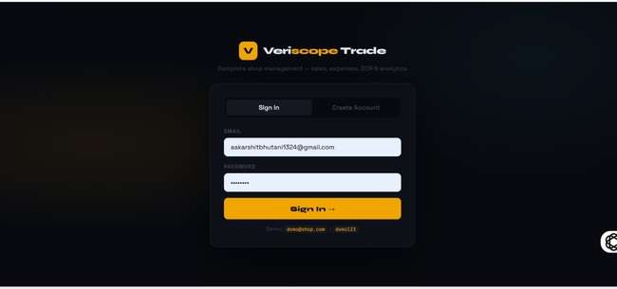2.Dashboard
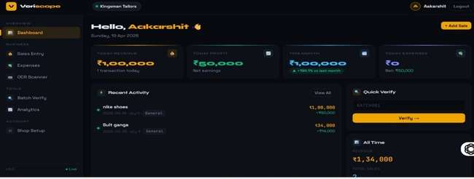
3.Sales Entry
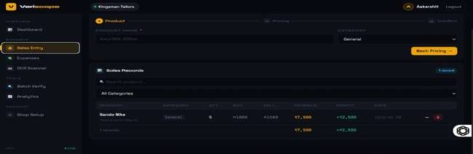
4.Batch Verification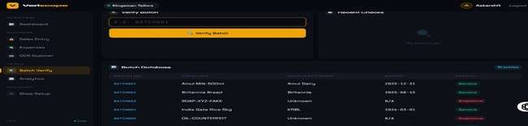
5.Shop Setup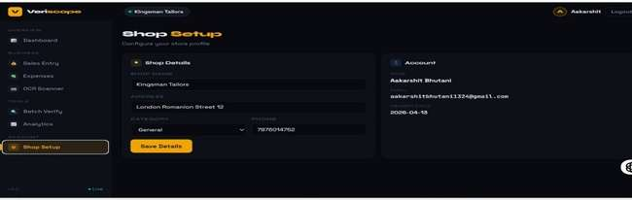
6. OCR Scanner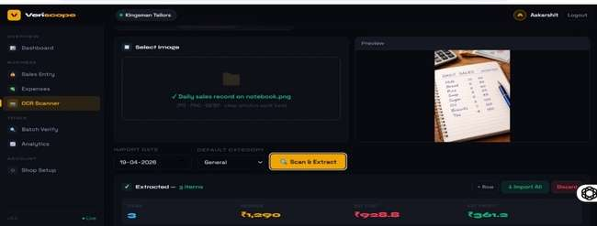
7. Sales Analytics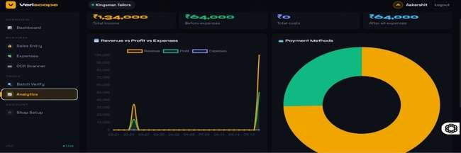
PROFILE OF TWO IT COMPANIES
1.Tata Consultancy Services (TCS):


Tata Consultancy Services (TCS) is one of the largest IT services and consulting companies in the world. It is part of the Tata Group and is headquartered in Mumbai, India.
Founded: 1968
Founder: J.R.D. Tata
CEO: K. Krithivasan
Services Offered:
- Software development
- IT consulting
- Cloud computing
- Artificial Intelligence & Machine Learning
- Cybersecurity services
- Business process outsourcing
Global Presence:
TCS operates in over 50 countries with hundreds of offices worldwide.
Key Features:
- Strong focus on innovation and research
- One of the biggest employers in India
- Trusted by global clients like banks, airlines, and governments
Role in Industry:
TCS is known for delivering scalable IT solutions and has played a major role in digital transformation globally.

2.Infosys

Infosys is a leading multinational IT company that provides business consulting, information technology, and outsourcing services.
Founded: 1981
Founder: Narayana Murthy and team
CEO: Salil Parekh
Services Offered:
- Software engineering
- Digital transformation
- Data analytics
- Cloud services
- AI and automation
- Enterprise solutions
Global Presence:
Infosys has offices in more than 45 countries and serves clients across industries.
Key Features:
- Strong training infrastructure (Infosys Mysore campus)
- Focus on innovation and sustainability

BIBLIOGRAPHY
1. Pressman, Roger S.
Software Engineering: A Practitioner’s Approach, 7th Edition, McGraw-Hill Education.
(Used for understanding software engineering concepts and system development models.)
2. Ian Sommerville
Software Engineering, 10th Edition, Pearson Education.
(Reference for system design, software requirements specification, and development paradigms.)
3. Flask Official Documentation
Available at: https://flask.palletsprojects.com
(Used for learning Flask framework and backend development.)
4. Python Software Foundation
Python Documentation.
Available at: https://docs.python.org
(Used for Python programming concepts and libraries.)
5.Tesseract OCR Documentation
Available at: https://github.com/tesseract-ocr/tesseract
(Reference for implementing OCR-based text extraction from images.)
6. Mozilla Developer Network (MDN)
Web Development Documentation.
Available at: https://developer.mozilla.org
(Used for HTML, CSS, and JavaScript development.)
7. W3Schools Online Web Tutorials
Available at: https://www.w3schools.com
(Used for learning frontend web development concepts.)
8. SQLite Documentation
Available at: https://www.sqlite.org/docs.html
(Reference for database design and query implementation.)
9. OpenCV Documentation
Available at: https://docs.opencv.org/
(Reference for image processing concepts.)
10. Pillow Documentation
Available at: https://pillow.readthedocs.io/en/stable/
(Used for image processing in OCR.)
11. Bootstrap Documentation
Available at: https://getbootstrap.com/docs/
(Responsive UI design concepts.)
12. JSON Documentation
Available at: https://www.json.org/json-en.html
(Data exchange format used in APIs.)
13. REST API Tutorial
Available at: https://restfulapi.net/
(Understanding REST API development.)
14. GitHub Documentation
Available at: https://docs.github.com/en
(Version control and collaboration.)
15. Stack Overflow
Available at: https://stackoverflow.com/
(Used for debugging and problem-solving.)
16. Lutz, Mark
Learning Python, O’Reilly Media.
Available at: https://www.oreilly.com/library/view/learning-python-5th/9781449355722/
(Comprehensive Python guide.)
17. Nielsen, Jakob
Usability Engineering, Morgan Kaufmann.
Available at: https://www.nngroup.com/books/usability-engineering/
(Improving user interface design.)
18. Shneiderman, Ben
Designing the User Interface, Pearson.
Available at: https://www.pearson.com/en-us/subject-catalog/p/designing-the-user-interface/P200000003433
(UI/UX design principles.)
19. Fielding, Roy T.
Architectural Styles and the Design of Network-based Software Architectures.
Available at: https://www.ics.uci.edu/~fielding/pubs/dissertation/top.htm
(Foundation of REST APIs.)
20. Kaggle
Available at: https://www.kaggle.com/
(Reference for data analytics concepts.)

